

**QUIZLET PROJECT**

**Software Design Specification**

– Hanoi, February 2023 –

**Record of changeS**

|  |  |  |  |
| --- | --- | --- | --- |
| Date | A* M, D | In charge | Change Description |
| 13/Feb | A | PhuongNV | * Create UI of folder page * CRUD folder * CRUD study sets in folders * Modified database |
| 13/Feb | A | AnhTHV | * Create UI screen home page before login page * Create UI of class screen * CRUD class |
| 13/Feb | A | GiangNH | * Create UI of footer * Search by study set name * Answers of professors * Create UI of answers of professors |
| 13/Feb | M, A | VuBL | * Create login, register * CRUD study sets * Modified animation, UI * Share study sets |
| 13/Feb | M, A | HungBM | * Modified a verify, login and register * Modified filter * Create your library * Forgot password |
| 24/Feb | M,A | PhuongNV | * Send Email * Change Password * Share links join folder |
| 24/Feb | M,A | HungBm | * Filter * Add study set into folder, class * Modified class in library |
| 24/Feb | M,A | AnhTHV | * CRUD folder in classes * Share link join class * Invite member * Send email join class |
| 19/Mar | A,D,M | VuBL | * Learn study set * Test study set * Show status learning of card * Modified sql |

|  |  |  |  |
| --- | --- | --- | --- |
| Date | A* M, D | In charge | Change Description |
| 13/Feb | A | PhuongNV | * Create UI of folder page * CRUD folder * CRUD study sets in folders * Modified database |
| 13/Feb | A | AnhTHV | * Create UI screen home page before login page * Create UI of class screen * CRUD class |
| 13/Feb | A | GiangNH | * Create UI of footer * Search by study set name * Answers of professors * Create UI of answers of professors |
| 13/Feb | M, A | VuBL | * Create login, register * CRUD study sets * Modified animation, UI * Share study sets |
| 13/Feb | M, A | HungBM | * Modified a verify, login and register * Modified filter * Create your library * Forgot password |

*A - Added M - Modified D - Deleted

**Table of Contents**

I. Overview 4

1. Code Packages 4

2. Database Design 4

a. Database Schema 4

b. Table Description 4

II. Code Designs 5

1. <Feature/Function Name1> 5

a. Class Diagram 5

b. Class Specifications 5

c. Sequence Diagram(s) 5

d. Database queries 6

2. <Feature/Function Name2> 6

# I. Overview

## 1. Code Packages

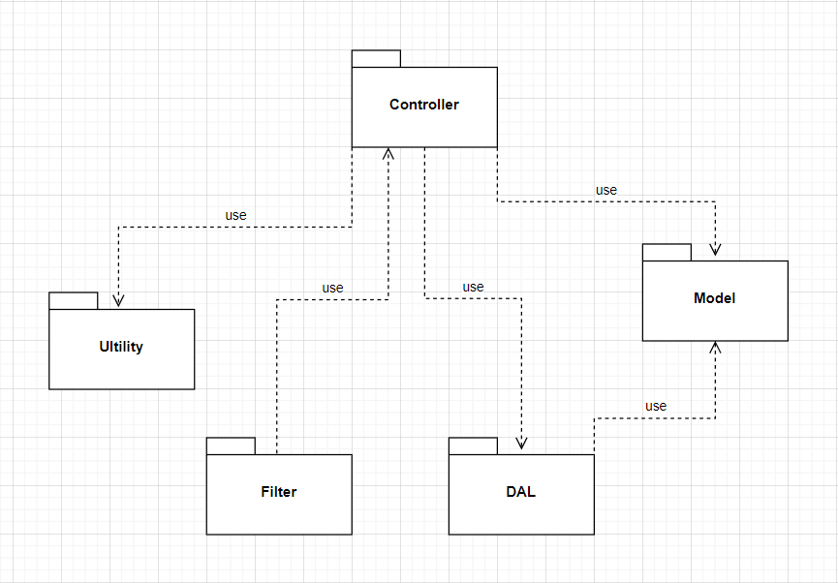

***Package descriptions***

|  |  |  |
| --- | --- | --- |
| **No** | **Package** | **Description** |
| *01* | *Controller* | *Controller package included Servlet file* |
| *02* | *Model* | *Model package support represent entities in database* |
| *03* | *DAL* | *DAL package included DBcontext and DAO* |
| *04* | *Ultility* | *Ultility package included some regex and verified file* |
| *05* | *Filter* | *Filter package included filter file to decentralize user and guest* |

## 2. Database Design

### a. Database Schema

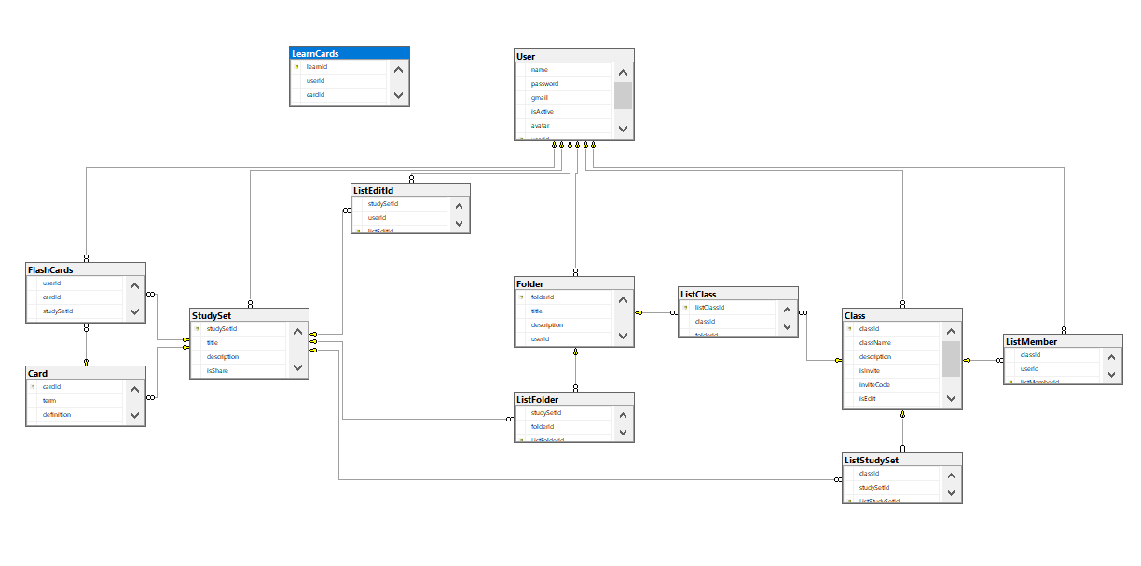

### b. Table Description

|  |  |  |
| --- | --- | --- |
| **#** | **Entity** | **Description** |
| 1 | User | All information of users |
| 2 | Card | All information of list cards |
| 3 | Study Set | All information of list study sets |
| 4 | Class | All information of list class |
| 5 | Folder | All information of list folder |
| 6 | List Folder | A folder contain study set and a study set can be in many different folder |
| 7 | List study set | A class contain study sets and a study set can be in many different class |
| 8 | List member | A class contain user and an user can join many class |
| 9 | List edit id | A user has many study sets |
| 10 | FlashCards | All information of cards in study set, which user were studied |
| 11 | ListClass | A class contain many folders and a folder can be in many different class |
| 12 | LearnCards | Cards were studied |

# 

# 

# II. Code Designs

## 1. Register

### a. Class Diagram

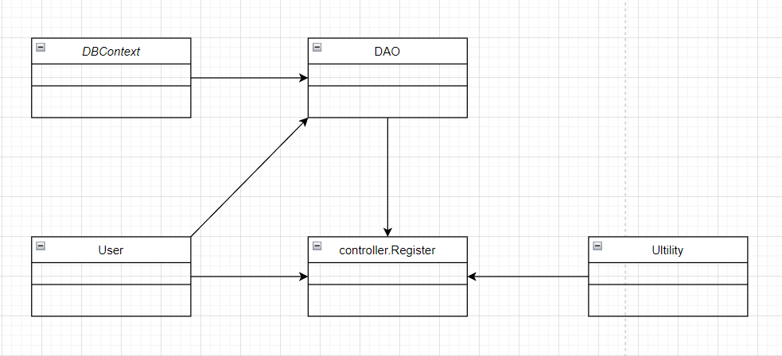

### b. Class Specifications

#### User Class

|  |  |  |
| --- | --- | --- |
| **No** | **Method** | **Description** |
| *01* | *User(){}* | Default constructor |
| *02* | *User(….){}* | *Parameterized constructor* |
| *03* | *getName(){}* | *Getter of Name* |
| *04* | *setName(string name){}* | *Setter of Name* |
| *05* | *getPass(){}* | *Getter of Pass* |
| *06* | *setPass(string pass){}* | *Setter of Pass* |
| *07* | *getEmail(){}* | *Getter email* |
| *08* | *setEmail(string email){}* | *Setter of email* |
| *09* | *isIsActive(){}* | *Getter of isActive* |
| *10* | *setIsActive(Boolean isActive){}* | *Setter of isActive* |
| *11* | *getAvatar(){}* | *Getter of avatar* |
| *12* | *setAvatar(string avatar)* | *Setter of avatar* |
| *13* | *getLanguage(){}* | *Getter of language* |
| *14* | *setLanguage(string language){}* | *Setter of language* |

#### Ultilities Class

***Class Methods***

|  |  |  |
| --- | --- | --- |
| **No** | **Method** | **Description** |
| *01* | *isBlank(string u){}* | *Check string is blank* |
| *02* | *checkExistEmail(string email){}* | *Check existed email* |
| *03* | *ValidInputRequire(string e, string p, string u){}* | *Check valid input* |
| *04* | *validEmail(string e){}* | *Check valid email* |
| *05* | *validUsername(string u){}* | *Check valid username* |
| *06* | *validPassword(string p){}* | *Check valid password* |

#### DAO Class

***Class Methods***

|  |  |  |
| --- | --- | --- |
| **No** | **Method** | **Description** |
| *01* | *register(user u){}* | *Insert new user to database* |
|  |  |  |

#### Register Controller Class

***Class Methods***

*[Provide the detailed description for the class methods]*

|  |  |  |
| --- | --- | --- |
| **No** | **Method** | **Description** |
| *01* | *Doget()* | *Sendredirect to register.jsp* |
| *02* | *doPost()* | *Check input and register* |

#### DBContext Class

***Class Methods***

*[Provide the detailed description for the class methods]*

|  |  |  |
| --- | --- | --- |
| **No** | **Method** | **Description** |
| *01* | *DBContext(){}* | *Connect to database* |

### c. Sequence Diagram(s)

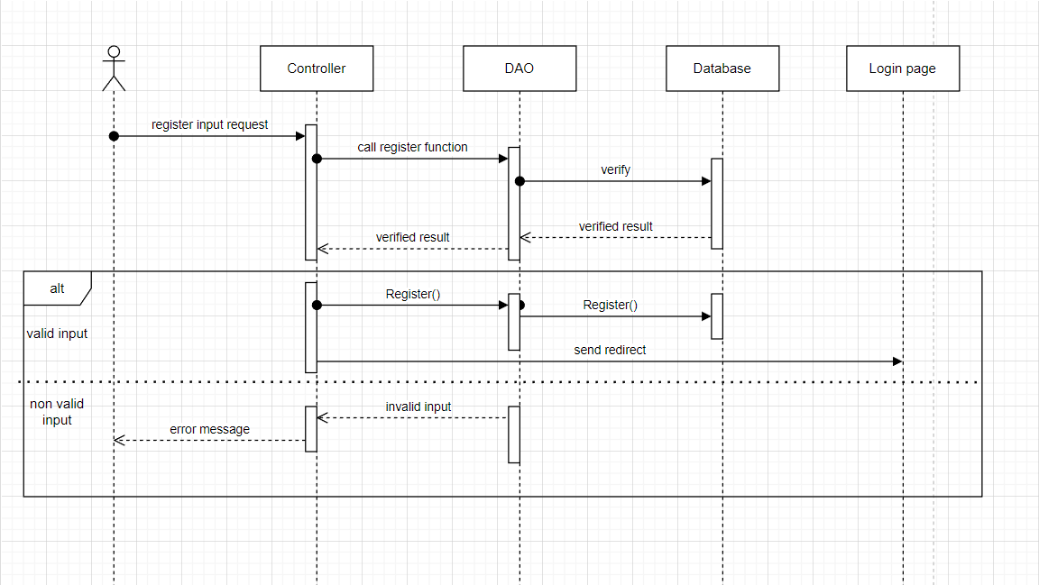

### d. Database Queries

*String sql = "INSERT INTO [dbo].[User]\n"*

*+ " ([name]\n"*

*+ " ,[password]\n"*

*+ " ,[gmail]\n"*

*+ " ,[isActive]\n"*

*+ " ,[avatar]\n"*

*+ " ,[language])\n"*

*+ " VALUES (?, ?, ?, ?, ?, ?)";*

## 

## 

## 

## 

## 

## 

## 2. Login

### a. Class Diagram

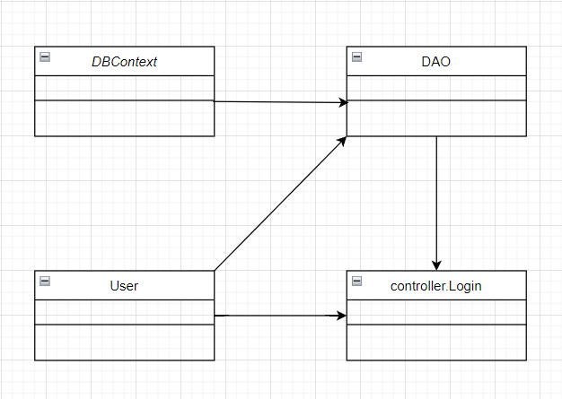

### b. Class Specifications

### User Class

|  |  |  |
| --- | --- | --- |
| **No** | **Method** | **Description** |
| *01* | *User(){}* | Default constructor |
| *02* | *User(….){}* | *Parameterized constructor* |
| *03* | *getName(){}* | *Getter of Name* |
| *04* | *setName(string name){}* | *Setter of Name* |
| *05* | *getPass(){}* | *Getter of Pass* |
| *06* | *setPass(string pass){}* | *Setter of Pass* |
| *07* | *getEmail(){}* | *Getter email* |
| *08* | *setEmail(string email){}* | *Setter of email* |
| *09* | *isIsActive(){}* | *Getter of isActive* |
| *10* | *setIsActive(Boolean isActive){}* | *Setter of isActive* |
| *11* | *getAvatar(){}* | *Getter of avatar* |
| *12* | *setAvatar(string avatar)* | *Setter of avatar* |
| *13* | *getLanguage(){}* | *Getter of language* |
| *14* | *setLanguage(string language){}* | *Setter of language* |

#### DBContext Class

|  |  |  |
| --- | --- | --- |
| **No** | **Method** | **Description** |
| *01* | *DBContext(){}* | *Connect to database* |

#### Register Controller Class

|  |  |  |
| --- | --- | --- |
| **No** | **Method** | **Description** |
| *01* | *Doget()* | *Get session and Send redirect to login.jsp* |
| *02* | *doPost()* | *Check input and login* |

#### DAO Class

|  |  |  |
| --- | --- | --- |
| **No** | **Method** | **Description** |
| *01* | *checkUser(username, password)* | *Check user have username, email, pass to login* |
| *02* | *GetAllUser()* | *Get all user in database* |

### c. Sequence Diagram(s)

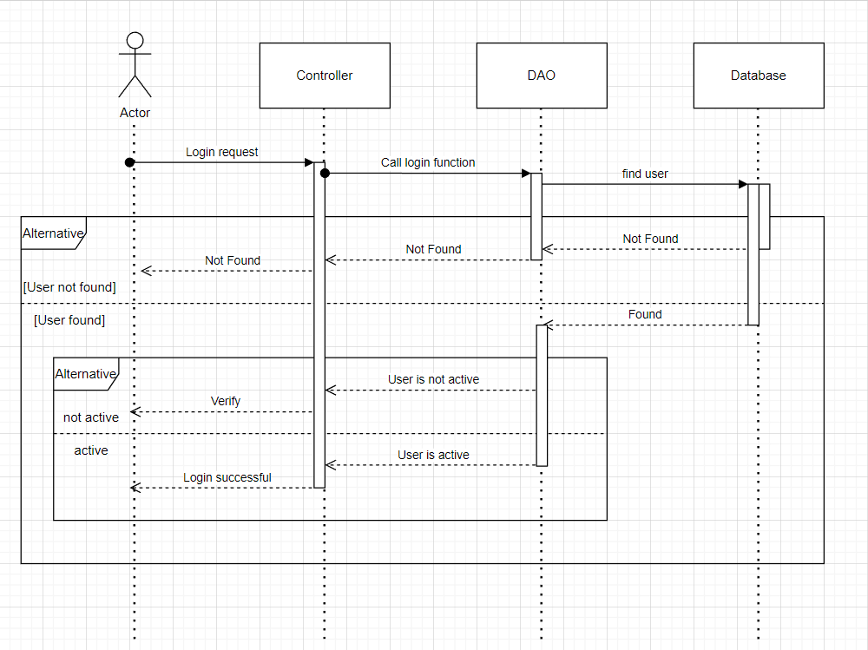

### d. Database Queries

## *select * from [User]*

## 3. Logout

### a. Class Diagram

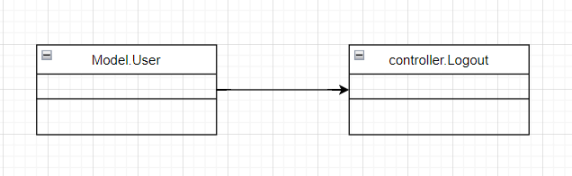

### b. Class Specifications

### User Class

|  |  |  |
| --- | --- | --- |
| **No** | **Method** | **Description** |
| *01* | *User(){}* | Default constructor |
| *02* | *User(….){}* | *Parameterized constructor* |
| *03* | *getName(){}* | *Getter of Name* |
| *04* | *setName(string name){}* | *Setter of Name* |
| *05* | *getPass(){}* | *Getter of Pass* |
| *06* | *setPass(string pass){}* | *Setter of Pass* |
| *07* | *getEmail(){}* | *Getter email* |
| *08* | *setEmail(string email){}* | *Setter of email* |
| *09* | *isIsActive(){}* | *Getter of isActive* |
| *10* | *setIsActive(Boolean isActive){}* | *Setter of isActive* |
| *11* | *getAvatar(){}* | *Getter of avatar* |
| *12* | *setAvatar(string avatar)* | *Setter of avatar* |
| *13* | *getLanguage(){}* | *Getter of language* |
| *14* | *setLanguage(string language){}* | *Setter of language* |

#### Register Controller Class

|  |  |  |
| --- | --- | --- |
| **No** | **Method** | **Description** |
| *01* | *Doget()* | *Remove session to logout* |

### c. Sequence Diagram(s)

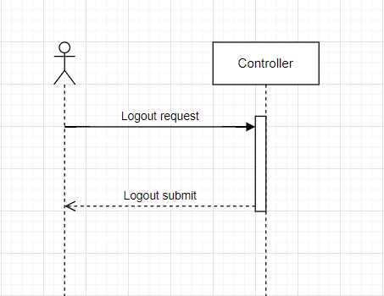

### d. Database Queries

*Logout function do not use database queries.*

## 4. Search study sets by name

### a. Class Diagram

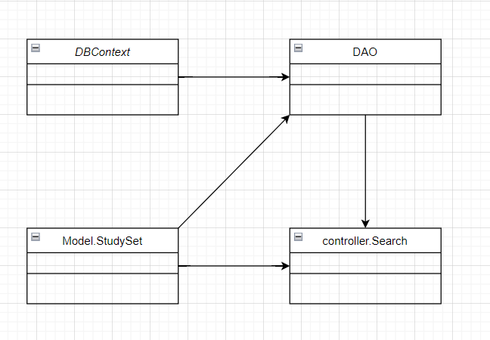

### b. Class Specifications

#### Study sets Class

|  |  |  |
| --- | --- | --- |
| **No** | **Method** | **Description** |
| *01* | *StudySet(){}* | *Default constructor* |
| *02* | *StudySet(….){}* | *Parameterized constructor* |
| *03* | *getId(){}* | *Getter of id* |
| *04* | *setId(int id){}* | *Setter of id* |
| *05* | *getTitle(){}* | *Getter of title* |
| *06* | *setTitle(string title){]* | *Setter of title* |
| *07* | *getDescription(){}* | *Getter of description* |
| *08* | *setDescription(string des){}* | *Setter of description* |
| *09* | *isIsShare(){}* | *Getter of isShare* |
| *10* | *setIsShare(Boolean isShare){]* | *Setter of isShare* |
| *11* | *getuserId(){}* | *Getter of user id* |
| *12* | *setUserid(int id){]* | *Setter of user id* |
| *13* | *getnumberCard(){}* | *Count number of cards in a study set* |
| *14* | *getAuthor(){}* | *Get name of user create study sets* |

#### Search controller Class

|  |  |  |
| --- | --- | --- |
| **No** | **Method** | **Description** |
| *01* | *doGet(){}* | *Search by name in list study sets* |
|  |  |  |

#### DAO Class

|  |  |  |
| --- | --- | --- |
| **No** | **Method** | **Description** |
| *01* | *getAllStudySet(){}* | *Get all study sets in database* |
|  |  |  |

#### DBContext Class

|  |  |  |
| --- | --- | --- |
| **No** | **Method** | **Description** |
| *01* | *DBContext(){}* | *Connect to database* |

### c. Sequence Diagram(s)

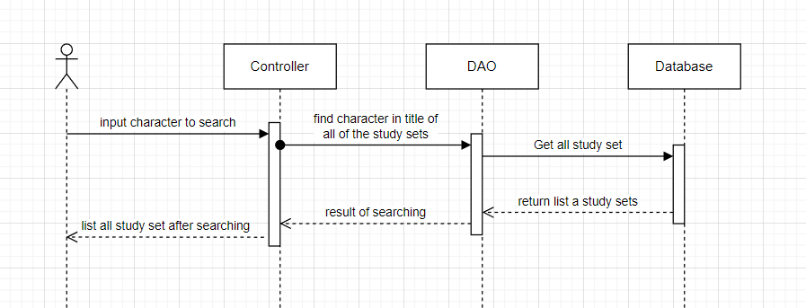

### d. Database Queries

# *Select * from StudySet*

## 5. Verify code

### a. Class Diagram

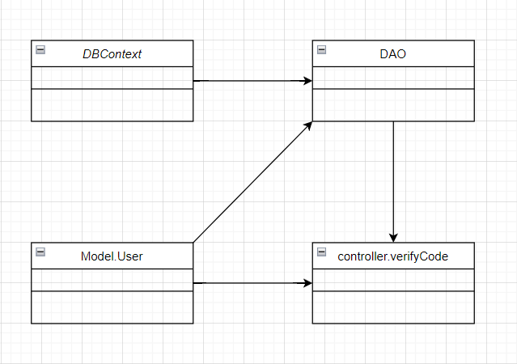

### b. Class Specifications

### User Class

|  |  |  |
| --- | --- | --- |
| **No** | **Method** | **Description** |
| *01* | *User(){}* | Default constructor |
| *02* | *User(….){}* | *Parameterized constructor* |
| *03* | *getName(){}* | *Getter of Name* |
| *04* | *setName(string name){}* | *Setter of Name* |
| *05* | *getPass(){}* | *Getter of Pass* |
| *06* | *setPass(string pass){}* | *Setter of Pass* |
| *07* | *getEmail(){}* | *Getter email* |
| *08* | *setEmail(string email){}* | *Setter of email* |
| *09* | *isIsActive(){}* | *Getter of isActive* |
| *10* | *setIsActive(Boolean isActive){}* | *Setter of isActive* |
| *11* | *getAvatar(){}* | *Getter of avatar* |
| *12* | *setAvatar(string avatar)* | *Setter of avatar* |
| *13* | *getLanguage(){}* | *Getter of language* |
| *14* | *setLanguage(string language){}* | *Setter of language* |

#### DBContext Class

|  |  |  |
| --- | --- | --- |
| **No** | **Method** | **Description** |
| *01* | *DBContext(){}* | *Connect to database* |

#### Verify controller Class

|  |  |  |
| --- | --- | --- |
| **No** | **Method** | **Description** |
| *01* | *doGet(){}* | *Send redirect to verify.jsp* |
| *02* | *doPost(){}* | *Active account by verify code* |

#### DAO Class

|  |  |  |
| --- | --- | --- |
| **No** | **Method** | **Description** |
| *01* | *Active account(string email){}* | *Update is active in database* |

### c. Sequence Diagram(s)

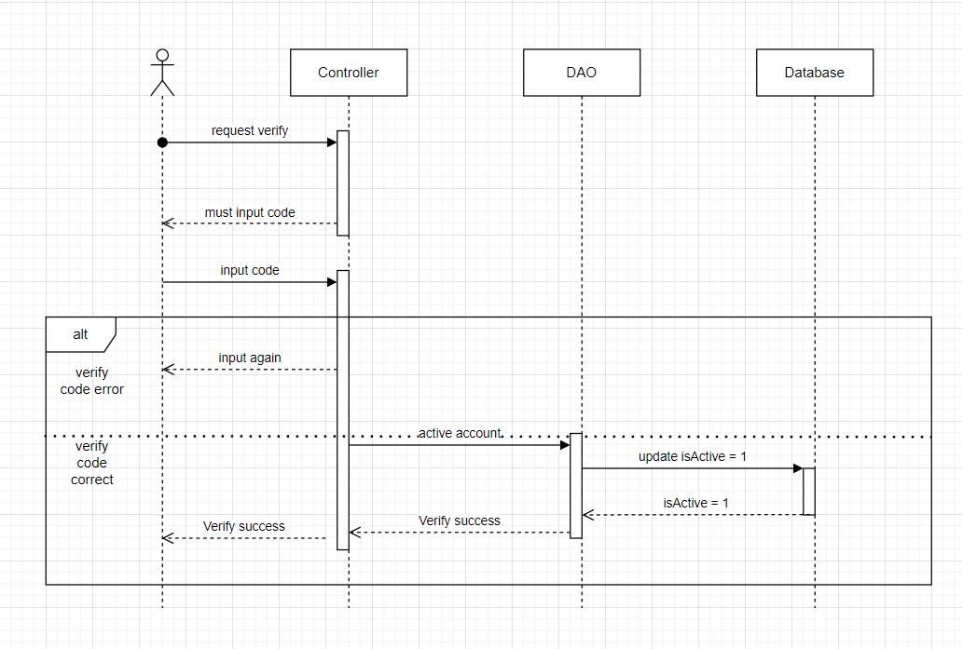

### d. Database Queries

*String sql = "update [User] set isActive = 1 where gmail like ?";*

## 6. FlashCard

### a. Class Diagram

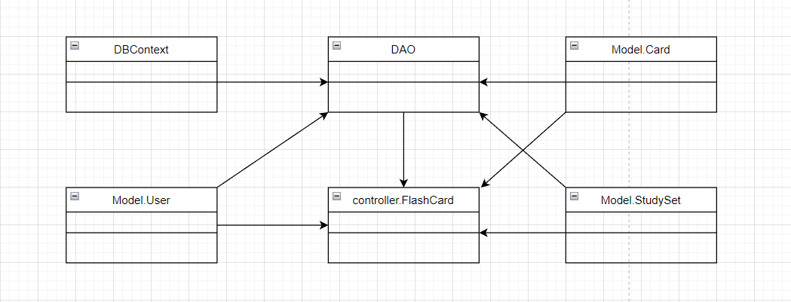

### b. Class Specifications

### User Class

|  |  |  |
| --- | --- | --- |
| **No** | **Method** | **Description** |
| *01* | *User(){}* | Default constructor |
| *02* | *User(….){}* | *Parameterized constructor* |
| *03* | *getName(){}* | *Getter of Name* |
| *04* | *setName(string name){}* | *Setter of Name* |
| *05* | *getPass(){}* | *Getter of Pass* |
| *06* | *setPass(string pass){}* | *Setter of Pass* |
| *07* | *getEmail(){}* | *Getter email* |
| *08* | *setEmail(string email){}* | *Setter of email* |
| *09* | *isIsActive(){}* | *Getter of isActive* |
| *10* | *setIsActive(Boolean isActive){}* | *Setter of isActive* |
| *11* | *getAvatar(){}* | *Getter of avatar* |
| *12* | *setAvatar(string avatar)* | *Setter of avatar* |
| *13* | *getLanguage(){}* | *Getter of language* |
| *14* | *setLanguage(string language){}* | *Setter of language* |

#### DBContext Class

|  |  |  |
| --- | --- | --- |
| **No** | **Method** | **Description** |
| *01* | *DBContext(){}* | *Connect to database* |

#### FlashCrard controller Class

|  |  |  |
| --- | --- | --- |
| **No** | **Method** | **Description** |
| *01* | *doGet(){}* | *Call function get all card in study sets* |

#### DAO Class

|  |  |  |
| --- | --- | --- |
| **No** | **Method** | **Description** |
| *01* | *getStudySetById(int id){}* | *Get study sets by its id* |
| *02* | *getUserByUserId(int id){}* | *Get user by id* |
| *03* | *getAllCardInSet(int id){}* | *Get all card in study set* |
| *04* | *getStudiedCard(int setId, int uId)* | *Get all studied cards* |

#### StudySet Class

|  |  |  |
| --- | --- | --- |
| **No** | **Method** | **Description** |
| *01* | *StudySet() {)* | *Default Constructor* |
| *02* | *StudySet(){.....}* | *Parameterized constructor* |
| *03* | *getId(){}* | *getter of StudySetId* |
| *04* | *setId(int id){}* | *setter of StudySetId* |
| *05* | *getTitle(){}* | *getter of Title* |
| *06* | *setTitle(string title){}* | *setter of Title* |
| *07* | *getDescription(){}* | *getter of Description* |
| *08* | *setDescription(string Description){}* | *setter of Description* |
| *09* | *isIsShare() {}* | *getter of isShare* |
| *10* | *setIsShare(boolean isShare) { }* | *setter of isShare* |
| *11* | *getUserId() { }* | *getter of UserId* |
| *12* | *setUserId(int userId) { }* | *setter of UserId* |
| *13* | *getNumberCard() {}* | *get number flashcard in studyset* |
| *14* | *String getAuthor() {}* | *get name of User created studyset* |

### Card Class

|  |  |  |
| --- | --- | --- |
| **No** | **Method** | **Description** |
| *01* | *Card() {)* | *Default Constructor* |
| *02* | *Card(){.....}* | *Parameterized constructor* |
| *03* | *getId(){}* | *getter of CardId* |
| *04* | *setId(int id){}* | *setter of CardId* |
| *05* | *getTerm(){}* | *getter of Term* |
| *06* | *setTerm(string term){}* | *setter of Term* |
| *07* | *getDefinition(){}* | *getter of Definition* |
| *08* | *setDefinition(string Definition){}* | *setter of Definition* |
| *09* | *getStudySetId() { }* | *getter of StudySetId* |
| *10* | *setStudySetId(int studySetId) { }* | *setter of StudySetId* |

### 

### c. Sequence Diagram(s)

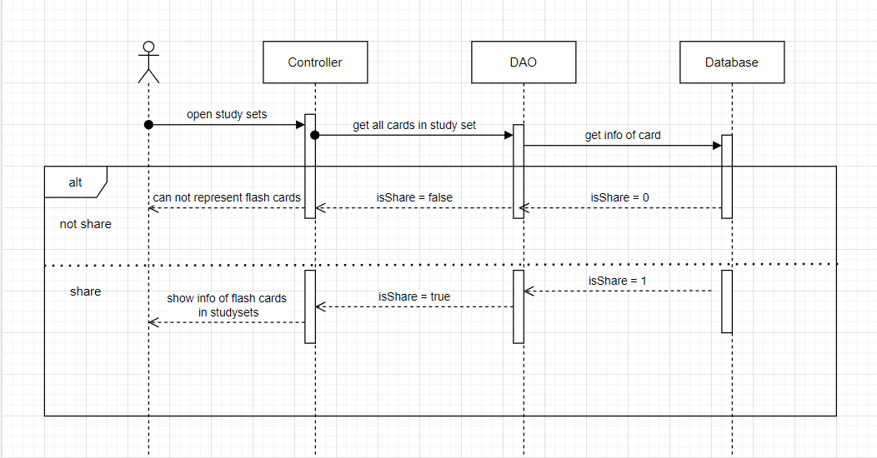

### d. Database Queries

*String sql = "SELECT [studySetId]\n"*

*+ " ,[title]\n"*

*+ " ,[description]\n"*

*+ " ,[isShare]\n"*

*+ " ,[userId]\n"*

*+ " FROM [dbo].[StudySet]\n"*

*+ " WHERE studySetId=?";*

*String sql = "SELECT [cardId]\n"*

*+ " ,[term]\n"*

*+ " ,[definition]\n"*

*+ " ,[studySetId]\n"*

*+ " FROM [dbo].[Card]\n"*

*+ " WHERE studySetID=?";*

*String sql = "SELECT [userId]\n"*

*+ " ,[cardId]\n"*

*+ " FROM [dbo].[FlashCards]"*

*+ " WHERE studySetId = ? and userId = ?";*

## 7.Create StudySet

### a. Class Diagram

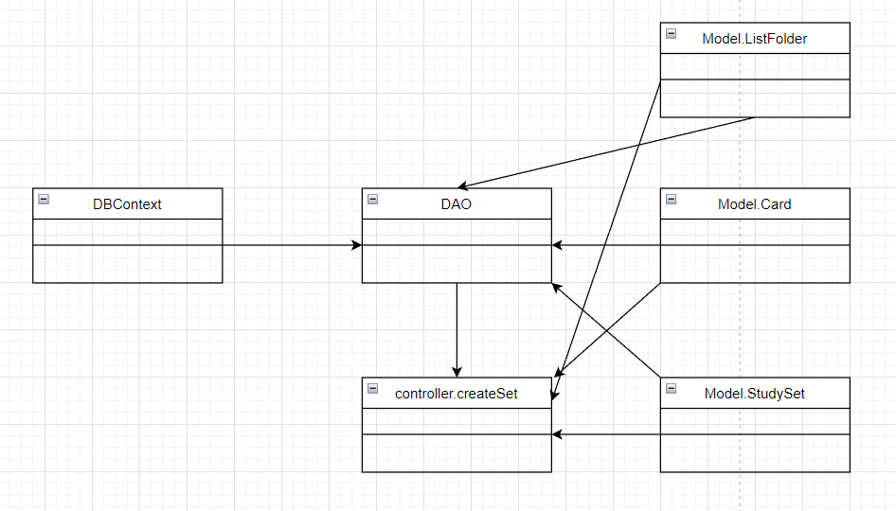

### b. Class Specifications

### User Class

|  |  |  |
| --- | --- | --- |
| **No** | **Method** | **Description** |
| *01* | *User(){}* | Default constructor |
| *02* | *User(….){}* | *Parameterized constructor* |
| *03* | *getName(){}* | *Getter of Name* |
| *04* | *setName(string name){}* | *Setter of Name* |
| *05* | *getPass(){}* | *Getter of Pass* |
| *06* | *setPass(string pass){}* | *Setter of Pass* |
| *07* | *getEmail(){}* | *Getter email* |
| *08* | *setEmail(string email){}* | *Setter of email* |
| *09* | *isIsActive(){}* | *Getter of isActive* |
| *10* | *setIsActive(Boolean isActive){}* | *Setter of isActive* |
| *11* | *getAvatar(){}* | *Getter of avatar* |
| *12* | *setAvatar(string avatar)* | *Setter of avatar* |
| *13* | *getLanguage(){}* | *Getter of language* |
| *14* | *setLanguage(string language){}* | *Setter of language* |

#### DBContext Class

|  |  |  |
| --- | --- | --- |
| **No** | **Method** | **Description** |
| *01* | *DBContext(){}* | *Connect to database* |

#### CreateSet controller Class

|  |  |  |
| --- | --- | --- |
| **No** | **Method** | **Description** |
| *01* | *doGet(){}* | *Fill info to card* |
| *02* | *doPost(){}* | *Add study set and card in set* |

#### DAO Class

|  |  |  |
| --- | --- | --- |
| **No** | **Method** | **Description** |
| *01* | *addStuySet(StudySet set){}* | *Add new study set* |
| *02* | *addCard(Card c){]* | *Add card to study set* |
| *03* | *createListFolder(listF){}* | *Add study set to a folder* |

#### StudySet Class

|  |  |  |
| --- | --- | --- |
| **No** | **Method** | **Description** |
| *01* | *StudySet() {)* | *Default Constructor* |
| *02* | *StudySet(){.....}* | *Parameterized constructor* |
| *03* | *getId(){}* | *getter of StudySetId* |
| *04* | *setId(int id){}* | *setter of StudySetId* |
| *05* | *getTitle(){}* | *getter of Title* |
| *06* | *setTitle(string title){}* | *setter of Title* |
| *07* | *getDescription(){}* | *getter of Description* |
| *08* | *setDescription(string Description){}* | *setter of Description* |
| *09* | *isIsShare() {}* | *getter of isShare* |
| *10* | *setIsShare(boolean isShare) { }* | *setter of isShare* |
| *11* | *getUserId() { }* | *getter of UserId* |
| *12* | *setUserId(int userId) { }* | *setter of UserId* |
| *13* | *getNumberCard() {}* | *get number flashcard in studyset* |
| *14* | *String getAuthor() {}* | *get name of User created studyset* |

### 

### Card Class

|  |  |  |
| --- | --- | --- |
| **No** | **Method** | **Description** |
| *01* | *Card() {)* | *Default Constructor* |
| *02* | *Card(){.....}* | *Parameterized constructor* |
| *03* | *getId(){}* | *getter of CardId* |
| *04* | *setId(int id){}* | *setter of CardId* |
| *05* | *getTerm(){}* | *getter of Term* |
| *06* | *setTerm(string term){}* | *setter of Term* |
| *07* | *getDefinition(){}* | *getter of Definition* |
| *08* | *setDefinition(string Definition){}* | *setter of Definition* |
| *09* | *getStudySetId() { }* | *getter of StudySetId* |
| *10* | *setStudySetId(int studySetId) { }* | *setter of StudySetId* |

### 

### c. Sequence Diagram(s)

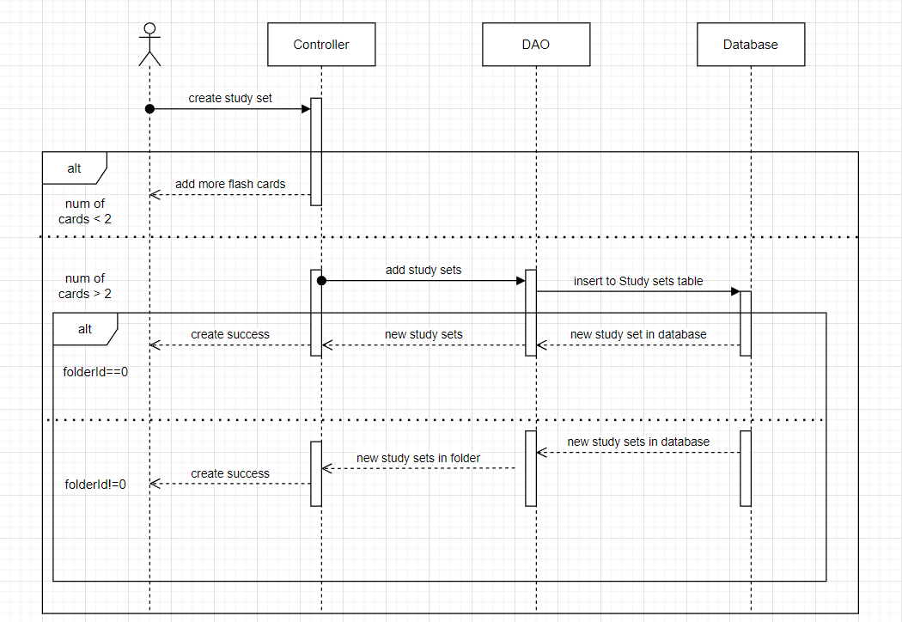

### d. Database Queries

*String sql = "INSERT INTO [dbo].[StudySet]\n"*

*+ " ([title]\n"*

*+ " ,[description]\n"*

*+ " ,[isShare]\n"*

*+ " ,[userId])\n"*

*+ " VALUES\n"*

*+ " (?\n"*

*+ " ,?\n"*

*+ " ,?\n"*

*+ " ,?)";*

*String sql = "INSERT INTO [dbo].[ListFolder]\n"*

*+ " ([studySetId]\n"*

*+ " ,[folderId])\n"*

*+ " VALUES(?,?)";*

## 8.Delete StudySet

### a. Class Diagram

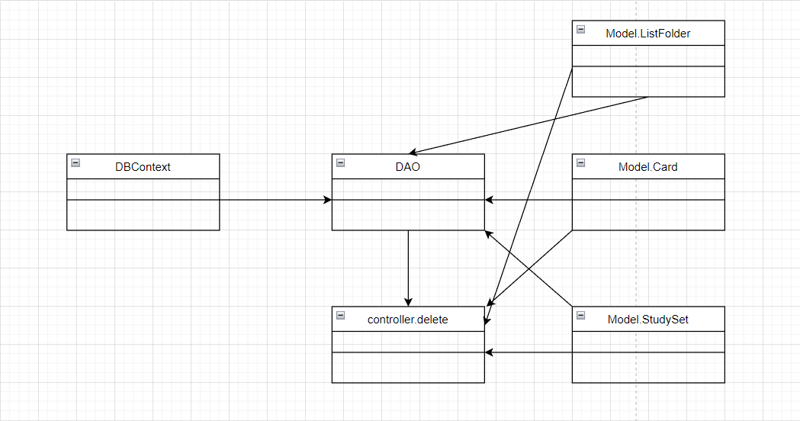

### b. Class Specifications

### User Class

|  |  |  |
| --- | --- | --- |
| **No** | **Method** | **Description** |
| *01* | *User(){}* | Default constructor |
| *02* | *User(….){}* | *Parameterized constructor* |
| *03* | *getName(){}* | *Getter of Name* |
| *04* | *setName(string name){}* | *Setter of Name* |
| *05* | *getPass(){}* | *Getter of Pass* |
| *06* | *setPass(string pass){}* | *Setter of Pass* |
| *07* | *getEmail(){}* | *Getter email* |
| *08* | *setEmail(string email){}* | *Setter of email* |
| *09* | *isIsActive(){}* | *Getter of isActive* |
| *10* | *setIsActive(Boolean isActive){}* | *Setter of isActive* |
| *11* | *getAvatar(){}* | *Getter of avatar* |
| *12* | *setAvatar(string avatar)* | *Setter of avatar* |
| *13* | *getLanguage(){}* | *Getter of language* |
| *14* | *setLanguage(string language){}* | *Setter of language* |

#### DBContext Class

|  |  |  |
| --- | --- | --- |
| **No** | **Method** | **Description** |
| *01* | *DBContext(){}* | *Connect to database* |

#### Delete controller Class

|  |  |  |
| --- | --- | --- |
| **No** | **Method** | **Description** |
| *01* | *doGet(){}* | *Delete card in study set, study set, and delete study set in folder* |

#### DAO Class

|  |  |  |
| --- | --- | --- |
| **No** | **Method** | **Description** |
| *01* | *deleteAllCards(int id){}* | *Delete all cards in study sets* |
| *02* | *deleteStudySet(int id){}* | *Delete study set* |
| *03* | *deleteInListFolder(int id){]* | *Delete study set in folders* |

#### StudySet Class

|  |  |  |
| --- | --- | --- |
| **No** | **Method** | **Description** |
| *01* | *StudySet() {)* | *Default Constructor* |
| *02* | *StudySet(){.....}* | *Parameterized constructor* |
| *03* | *getId(){}* | *getter of StudySetId* |
| *04* | *setId(int id){}* | *setter of StudySetId* |
| *05* | *getTitle(){}* | *getter of Title* |
| *06* | *setTitle(string title){}* | *setter of Title* |
| *07* | *getDescription(){}* | *getter of Description* |
| *08* | *setDescription(string Description){}* | *setter of Description* |
| *09* | *isIsShare() {}* | *getter of isShare* |
| *10* | *setIsShare(boolean isShare) { }* | *setter of isShare* |
| *11* | *getUserId() { }* | *getter of UserId* |
| *12* | *setUserId(int userId) { }* | *setter of UserId* |
| *13* | *getNumberCard() {}* | *get number flashcard in studyset* |
| *14* | *String getAuthor() {}* | *get name of User created studyset* |

### 

### Card Class

|  |  |  |
| --- | --- | --- |
| **No** | **Method** | **Description** |
| *01* | *Card() {)* | *Default Constructor* |
| *02* | *Card(){.....}* | *Parameterized constructor* |
| *03* | *getId(){}* | *getter of CardId* |
| *04* | *setId(int id){}* | *setter of CardId* |
| *05* | *getTerm(){}* | *getter of Term* |
| *06* | *setTerm(string term){}* | *setter of Term* |
| *07* | *getDefinition(){}* | *getter of Definition* |
| *08* | *setDefinition(string Definition){}* | *setter of Definition* |
| *09* | *getStudySetId() { }* | *getter of StudySetId* |
| *10* | *setStudySetId(int studySetId) { }* | *setter of StudySetId* |

### 

### c. Sequence Diagram(s)

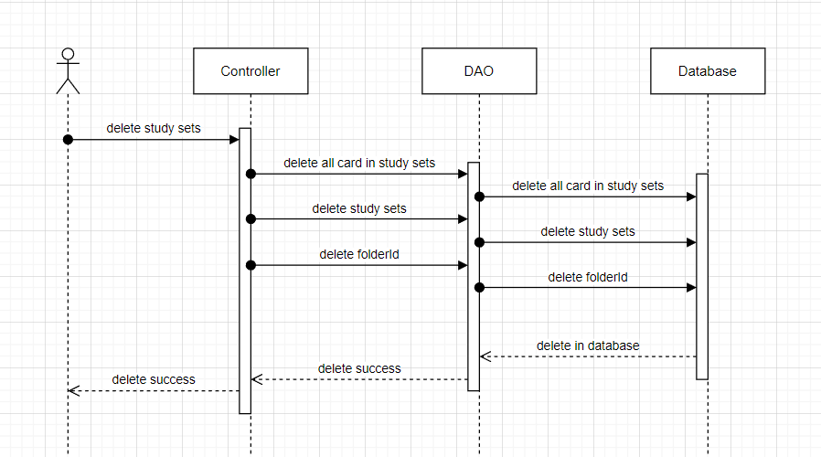

### d. Database Queries

*String sql = "DELETE FROM [dbo].[ListFolder]\n"*

*+ " WHERE studySetId = ?";*

*String sql = "DELETE FROM [dbo].[Card]\n"*

*+ " WHERE studySetId=?";*

*String sql = "DELETE FROM [dbo].[StudySet]\n"*

*+ " WHERE studySetId=?";*

## 9.Add Studied Cards

### a. Class Diagram

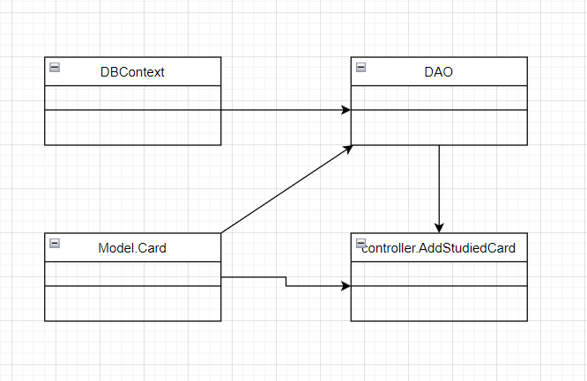

### b. Class Specifications

### User Class

|  |  |  |
| --- | --- | --- |
| **No** | **Method** | **Description** |
| *01* | *User(){}* | Default constructor |
| *02* | *User(….){}* | *Parameterized constructor* |
| *03* | *getName(){}* | *Getter of Name* |
| *04* | *setName(string name){}* | *Setter of Name* |
| *05* | *getPass(){}* | *Getter of Pass* |
| *06* | *setPass(string pass){}* | *Setter of Pass* |
| *07* | *getEmail(){}* | *Getter email* |
| *08* | *setEmail(string email){}* | *Setter of email* |
| *09* | *isIsActive(){}* | *Getter of isActive* |
| *10* | *setIsActive(Boolean isActive){}* | *Setter of isActive* |
| *11* | *getAvatar(){}* | *Getter of avatar* |
| *12* | *setAvatar(string avatar)* | *Setter of avatar* |
| *13* | *getLanguage(){}* | *Getter of language* |
| *14* | *setLanguage(string language){}* | *Setter of language* |

#### DBContext Class

|  |  |  |
| --- | --- | --- |
| **No** | **Method** | **Description** |
| *01* | *DBContext(){}* | *Connect to database* |

#### AddStudiedCard controller Class

|  |  |  |
| --- | --- | --- |
| **No** | **Method** | **Description** |
| *01* | *doGet(){}* | *Add all studied card to a list* |

#### DAO Class

|  |  |  |
| --- | --- | --- |
| **No** | **Method** | **Description** |
| *01* | *getAllCardinSet(int id){}* | *Get all card in study set* |
| *02* | *getListStudiedCardId(int sid, int uid){}* | *Get list all studied card id* |
| *03* | *addStudiedCard(int uid, int id, studySetId){}* | *Add all studied card to a list* |

#### StudySet Class

|  |  |  |
| --- | --- | --- |
| **No** | **Method** | **Description** |
| *01* | *StudySet() {)* | *Default Constructor* |
| *02* | *StudySet(){.....}* | *Parameterized constructor* |
| *03* | *getId(){}* | *getter of StudySetId* |
| *04* | *setId(int id){}* | *setter of StudySetId* |
| *05* | *getTitle(){}* | *getter of Title* |
| *06* | *setTitle(string title){}* | *setter of Title* |
| *07* | *getDescription(){}* | *getter of Description* |
| *08* | *setDescription(string Description){}* | *setter of Description* |
| *09* | *isIsShare() {}* | *getter of isShare* |
| *10* | *setIsShare(boolean isShare) { }* | *setter of isShare* |
| *11* | *getUserId() { }* | *getter of UserId* |
| *12* | *setUserId(int userId) { }* | *setter of UserId* |
| *13* | *getNumberCard() {}* | *get number flashcard in studyset* |
| *14* | *String getAuthor() {}* | *get name of User created studyset* |

### 

### Card Class

|  |  |  |
| --- | --- | --- |
| **No** | **Method** | **Description** |
| *01* | *Card() {)* | *Default Constructor* |
| *02* | *Card(){.....}* | *Parameterized constructor* |
| *03* | *getId(){}* | *getter of CardId* |
| *04* | *setId(int id){}* | *setter of CardId* |
| *05* | *getTerm(){}* | *getter of Term* |
| *06* | *setTerm(string term){}* | *setter of Term* |
| *07* | *getDefinition(){}* | *getter of Definition* |
| *08* | *setDefinition(string Definition){}* | *setter of Definition* |
| *09* | *getStudySetId() { }* | *getter of StudySetId* |
| *10* | *setStudySetId(int studySetId) { }* | *setter of StudySetId* |

### 

### c. Sequence Diagram(s)

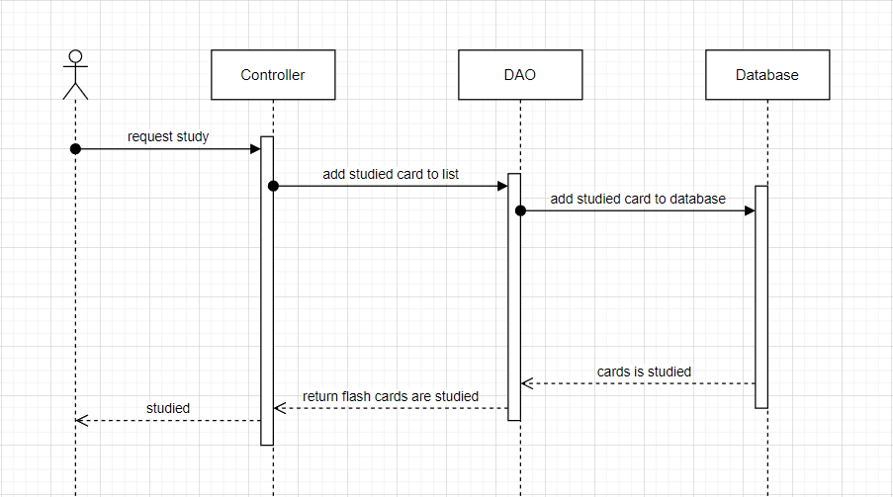

### d. Database Queries

*String sql = "SELECT [cardId]\n"*

*+ " ,[term]\n"*

*+ " ,[definition]\n"*

*+ " ,[studySetId]\n"*

*+ " FROM [dbo].[Card]\n"*

*+ " WHERE studySetID=?";*

*String sql = "SELECT [userId]\n"*

*+ " ,[cardId]\n"*

*+ " FROM [dbo].[FlashCards]"*

*+ " WHERE studySetId = ? and userId = ?";*

*String sql = "INSERT INTO [dbo].[FlashCards]\n"*

*+ " ([userId]\n"*

*+ " ,[cardId]\n"*

*+ " ,[studySetId])\n"*

*+ " VALUES(?,?,?)";*

## 10.Forget password

### a. Class Diagram

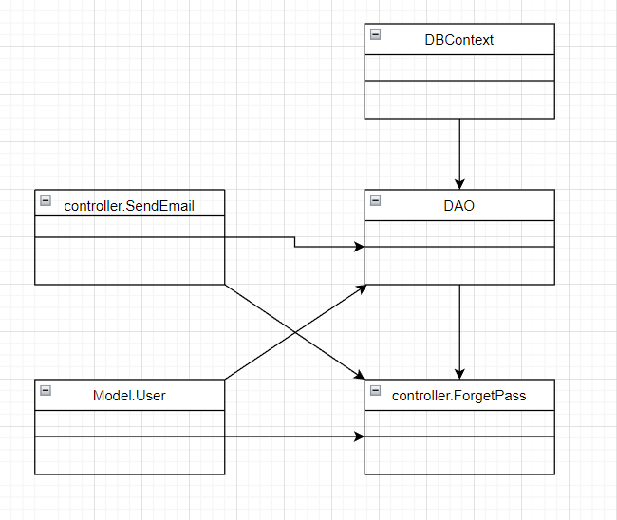

### b. Class Specifications

### User Class

|  |  |  |
| --- | --- | --- |
| **No** | **Method** | **Description** |
| *01* | *User(){}* | Default constructor |
| *02* | *User(….){}* | *Parameterized constructor* |
| *03* | *getName(){}* | *Getter of Name* |
| *04* | *setName(string name){}* | *Setter of Name* |
| *05* | *getPass(){}* | *Getter of Pass* |
| *06* | *setPass(string pass){}* | *Setter of Pass* |
| *07* | *getEmail(){}* | *Getter email* |
| *08* | *setEmail(string email){}* | *Setter of email* |
| *09* | *isIsActive(){}* | *Getter of isActive* |
| *10* | *setIsActive(Boolean isActive){}* | *Setter of isActive* |
| *11* | *getAvatar(){}* | *Getter of avatar* |
| *12* | *setAvatar(string avatar)* | *Setter of avatar* |
| *13* | *getLanguage(){}* | *Getter of language* |
| *14* | *setLanguage(string language){}* | *Setter of language* |

#### DBContext Class

|  |  |  |
| --- | --- | --- |
| **No** | **Method** | **Description** |
| *01* | *DBContext(){}* | *Connect to database* |

#### FogetPass controller Class

|  |  |  |
| --- | --- | --- |
| **No** | **Method** | **Description** |
| *01* | *doPost(){}* | *Send link change password to email of user* |

#### DAO Class

|  |  |  |
| --- | --- | --- |
| **No** | **Method** | **Description** |
| *01* | *checkUser(string email){}* | *Check email in database* |

#### SendEmail Class

|  |  |  |
| --- | --- | --- |
| **No** | **Method** | **Description** |
| *01* | *SendEmailPass(){}* | *Send link to change password to user* |

### 

### c. Sequence Diagram(s)

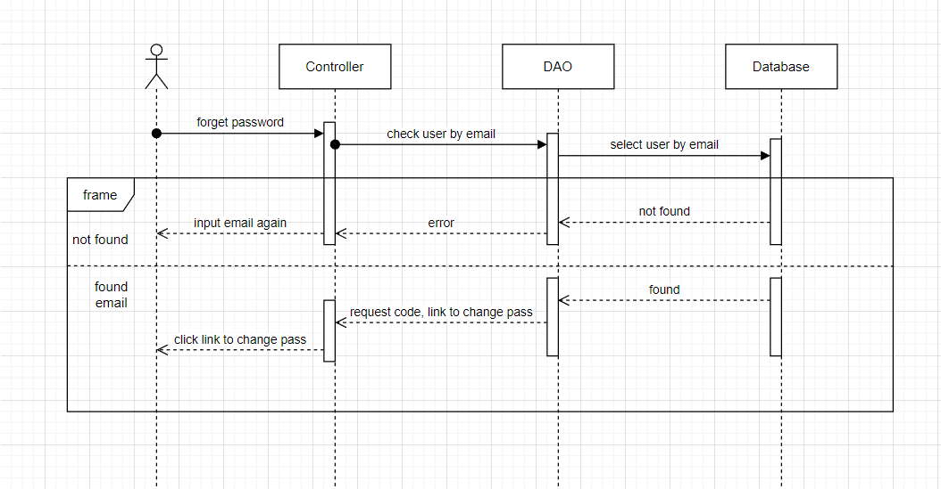

### d. Database Queries

*String sql = "select * from [User] where gmail =? ";*

## 11.Change password

### a. Class Diagram

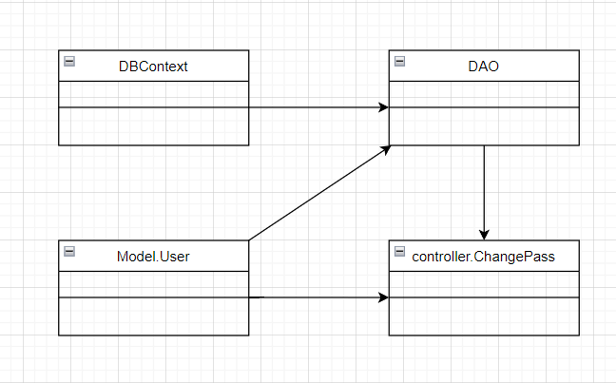

### b. Class Specifications

### User Class

|  |  |  |
| --- | --- | --- |
| **No** | **Method** | **Description** |
| *01* | *User(){}* | Default constructor |
| *02* | *User(….){}* | *Parameterized constructor* |
| *03* | *getName(){}* | *Getter of Name* |
| *04* | *setName(string name){}* | *Setter of Name* |
| *05* | *getPass(){}* | *Getter of Pass* |
| *06* | *setPass(string pass){}* | *Setter of Pass* |
| *07* | *getEmail(){}* | *Getter email* |
| *08* | *setEmail(string email){}* | *Setter of email* |
| *09* | *isIsActive(){}* | *Getter of isActive* |
| *10* | *setIsActive(Boolean isActive){}* | *Setter of isActive* |
| *11* | *getAvatar(){}* | *Getter of avatar* |
| *12* | *setAvatar(string avatar)* | *Setter of avatar* |
| *13* | *getLanguage(){}* | *Getter of language* |
| *14* | *setLanguage(string language){}* | *Setter of language* |

#### DBContext Class

|  |  |  |
| --- | --- | --- |
| **No** | **Method** | **Description** |
| *01* | *DBContext(){}* | *Connect to database* |

#### ChangePass controller Class

|  |  |  |
| --- | --- | --- |
| **No** | **Method** | **Description** |
| *01* | *doGet(){}* | *Check code verify when send email* |
| *02* | *doPost(){}* | *Change password* |

#### DAO Class

|  |  |  |
| --- | --- | --- |
| **No** | **Method** | **Description** |
| *01* | *getIdByEmail(string email){}* | *Get id of user by email* |
| *02* | *updatePass(string pass, int uId){}* | *Update new password* |

### 

### 

### c. Sequence Diagram(s)

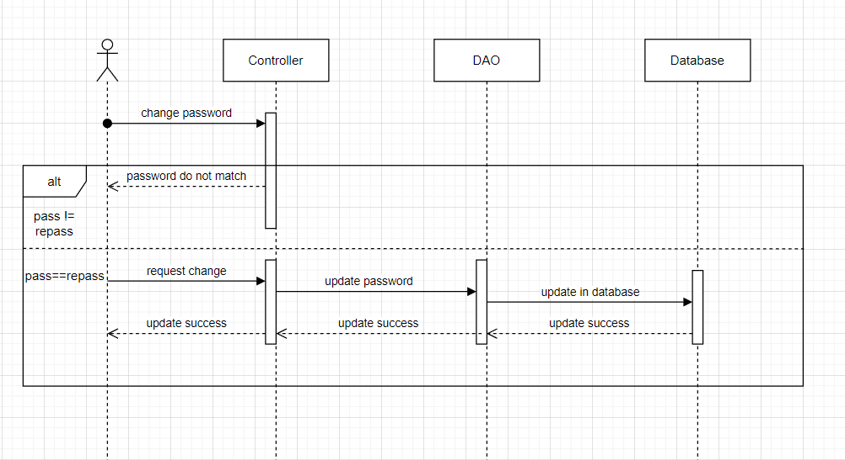

### d. Database Queries

*String sql = "UPDATE [User]\n"*

*+ "SET\n"*

*+ "\n"*

*+ "password = ?\n"*

*+ "\n"*

*+ "WHERE userId = ?";*

## 12.Update studyset

### a. Class Diagram

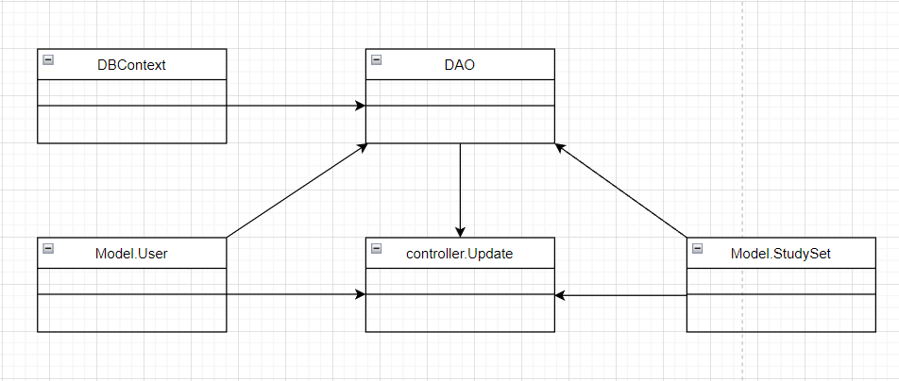

### b. Class Specifications

### User Class

|  |  |  |
| --- | --- | --- |
| **No** | **Method** | **Description** |
| *01* | *User(){}* | Default constructor |
| *02* | *User(….){}* | *Parameterized constructor* |
| *03* | *getName(){}* | *Getter of Name* |
| *04* | *setName(string name){}* | *Setter of Name* |
| *05* | *getPass(){}* | *Getter of Pass* |
| *06* | *setPass(string pass){}* | *Setter of Pass* |
| *07* | *getEmail(){}* | *Getter email* |
| *08* | *setEmail(string email){}* | *Setter of email* |
| *09* | *isIsActive(){}* | *Getter of isActive* |
| *10* | *setIsActive(Boolean isActive){}* | *Setter of isActive* |
| *11* | *getAvatar(){}* | *Getter of avatar* |
| *12* | *setAvatar(string avatar)* | *Setter of avatar* |
| *13* | *getLanguage(){}* | *Getter of language* |
| *14* | *setLanguage(string language){}* | *Setter of language* |

#### DBContext Class

|  |  |  |
| --- | --- | --- |
| **No** | **Method** | **Description** |
| *01* | *DBContext(){}* | *Connect to database* |

#### Update controller Class

|  |  |  |
| --- | --- | --- |
| **No** | **Method** | **Description** |
| *01* | *doGet(){}* | *Get information of all card in study set to update* |
| *02* | *doPost(){}* | *Update or add new cards in study set* |

#### DAO Class

|  |  |  |
| --- | --- | --- |
| **No** | **Method** | **Description** |
| *01* | *getStudySetByID(int id){}* | *Get study set by study set id* |
| *02* | *getAllCardInSet(int id){}* | *Get all cards in study set* |
| *03* | *updateStudySet(studyset s){}* | *Update study set* |
| *04* | *updateCard(Card c){}* | *Update cards in study set* |
| *05* | *addCard(Card c){}* | *Add more cards in study sets* |
|  |  |  |

#### StudySet Class

|  |  |  |
| --- | --- | --- |
| **No** | **Method** | **Description** |
| *01* | *StudySet() {)* | *Default Constructor* |
| *02* | *StudySet(){.....}* | *Parameterized constructor* |
| *03* | *getId(){}* | *getter of StudySetId* |
| *04* | *setId(int id){}* | *setter of StudySetId* |
| *05* | *getTitle(){}* | *getter of Title* |
| *06* | *setTitle(string title){}* | *setter of Title* |
| *07* | *getDescription(){}* | *getter of Description* |
| *08* | *setDescription(string Description){}* | *setter of Description* |
| *09* | *isIsShare() {}* | *getter of isShare* |
| *10* | *setIsShare(boolean isShare) { }* | *setter of isShare* |
| *11* | *getUserId() { }* | *getter of UserId* |
| *12* | *setUserId(int userId) { }* | *setter of UserId* |
| *13* | *getNumberCard() {}* | *get number flashcard in studyset* |
| *14* | *String getAuthor() {}* | *get name of User created studyset* |

### 

### 

### Card Class

|  |  |  |
| --- | --- | --- |
| **No** | **Method** | **Description** |
| *01* | *Card() {)* | *Default Constructor* |
| *02* | *Card(){.....}* | *Parameterized constructor* |
| *03* | *getId(){}* | *getter of CardId* |
| *04* | *setId(int id){}* | *setter of CardId* |
| *05* | *getTerm(){}* | *getter of Term* |
| *06* | *setTerm(string term){}* | *setter of Term* |
| *07* | *getDefinition(){}* | *getter of Definition* |
| *08* | *setDefinition(string Definition){}* | *setter of Definition* |
| *09* | *getStudySetId() { }* | *getter of StudySetId* |
| *10* | *setStudySetId(int studySetId) { }* | *setter of StudySetId* |

### 

### 

### 

### c. Sequence Diagram(s)

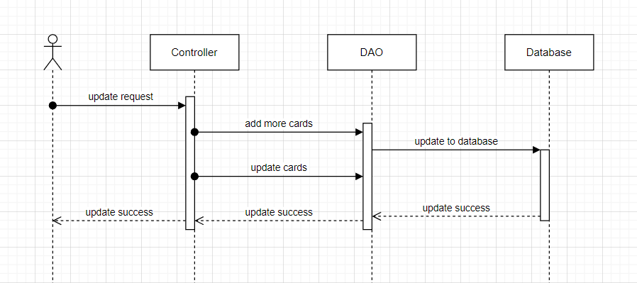

### d. Database Queries

*String sql = "UPDATE [dbo].[StudySet]\n"*

*+ " SET [title] = ?\n"*

*+ " ,[description] = ?\n"*

*+ " ,[isShare] = ?\n"*

*+ " WHERE studySetId=?";*

## 13.Home

### a. Class Diagram

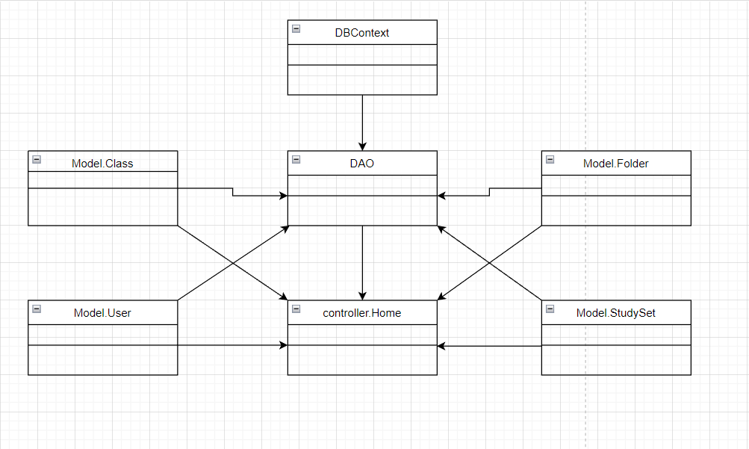

### b. Class Specifications

### User Class

|  |  |  |
| --- | --- | --- |
| **No** | **Method** | **Description** |
| *01* | *User(){}* | Default constructor |
| *02* | *User(….){}* | *Parameterized constructor* |
| *03* | *getName(){}* | *Getter of Name* |
| *04* | *setName(string name){}* | *Setter of Name* |
| *05* | *getPass(){}* | *Getter of Pass* |
| *06* | *setPass(string pass){}* | *Setter of Pass* |
| *07* | *getEmail(){}* | *Getter email* |
| *08* | *setEmail(string email){}* | *Setter of email* |
| *09* | *isIsActive(){}* | *Getter of isActive* |
| *10* | *setIsActive(Boolean isActive){}* | *Setter of isActive* |
| *11* | *getAvatar(){}* | *Getter of avatar* |
| *12* | *setAvatar(string avatar)* | *Setter of avatar* |
| *13* | *getLanguage(){}* | *Getter of language* |
| *14* | *setLanguage(string language){}* | *Setter of language* |

#### DBContext Class

|  |  |  |
| --- | --- | --- |
| **No** | **Method** | **Description** |
| *01* | *DBContext(){}* | *Connect to database* |

#### Home controller Class

|  |  |  |
| --- | --- | --- |
| **No** | **Method** | **Description** |
| *01* | *doGet(){}* | *List all studySet and your library* |

#### DAO Class

|  |  |  |
| --- | --- | --- |
| **No** | **Method** | **Description** |
| *01* | *getAllStudySet(string email){}* | *Get all study set* |
| *02* | *getFiveStudySet(int id){}* | *Get top 5 study set order by id* |
| *03* | *getUserByUserID(int id){}* | *Get user by user id* |
| *04* | *getTopFiveFolder(int id){}* | *Get top 5 folder order by id* |

#### StudySet Class

|  |  |  |
| --- | --- | --- |
| **No** | **Method** | **Description** |
| *01* | *StudySet() {)* | *Default Constructor* |
| *02* | *StudySet(){.....}* | *Parameterized constructor* |
| *03* | *getId(){}* | *getter of StudySetId* |
| *04* | *setId(int id){}* | *setter of StudySetId* |
| *05* | *getTitle(){}* | *getter of Title* |
| *06* | *setTitle(string title){}* | *setter of Title* |
| *07* | *getDescription(){}* | *getter of Description* |
| *08* | *setDescription(string Description){}* | *setter of Description* |
| *09* | *isIsShare() {}* | *getter of isShare* |
| *10* | *setIsShare(boolean isShare) { }* | *setter of isShare* |
| *11* | *getUserId() { }* | *getter of UserId* |
| *12* | *setUserId(int userId) { }* | *setter of UserId* |
| *13* | *getNumberCard() {}* | *get number flashcard in studyset* |
| *14* | *String getAuthor() {}* | *get name of User created studyset* |

### 

### 

### Folder Class

|  |  |  |
| --- | --- | --- |
| **No** | **Method** | **Description** |
| *01* | *Folder() {)* | *Default Constructor* |
| *02* | *Folder(){.....}* | *Parameterized constructor* |
| *03* | *getId(){}* | *getter of CardId* |
| *04* | *setId(int id){}* | *setter of CardId* |
| *05* | *getTitle(){}* | *getter of Title* |
| *06* | *setTitle(string term){}* | *setter of Title* |
| *07* | *getDescription(){}* | *getter of Description* |
| *08* | *setDescription(string Definition){}* | *setter of Description* |
| *09* | *getUserId() { }* | *getter of UserId* |
| *10* | *setUserId(int UserId) { }* | *setter of UserId* |

### 

### Class Class

|  |  |  |
| --- | --- | --- |
| **No** | **Method** | **Description** |
| *01* | *Class() {)* | *Default Constructor* |
| *02* | *Class(){.....}* | *Parameterized constructor* |
| *03* | *getId(){}* | *getter of Class Id* |
| *04* | *setId(int id){}* | *setter of Class Id* |
| *05* | *getName(){}* | *getter of Class Name* |
| *06* | *setName(string name){}* | *setter of Class Name* |
| *07* | *getDesc(){}* | *getter of Desc* |
| *08* | *setDesc(string Desc){}* | *setter of Desc* |
| *09* | *getUserId() { }* | *getter of UserId* |
| *10* | *setUserId(int UserId) { }* | *setter of UserId* |
| *11* | *isIsInvite() {}* | *getter of isInvite* |
| *12* | *setIsInvite(boolean isInvite) { }* | *setter of isInvite* |
| *13* | *isIsEdit() {}* | *getter of isEdit* |
| *14* | *setIsEdit(boolean isEdit) { }* | *setter of isEdit* |
| *15* | *getInviteCode() {}* | *getter of inviteCode* |
| *16* | *setInviteCode(string inviteCode) { }* | *setter of inviteCode* |
| *17* | *getSchoolName() {}* | *getter of schoolName* |
| *18* | *setSchoolName(string inviteCode) { }* | *setter of schoolName* |

### 

### c. Sequence Diagram(s)

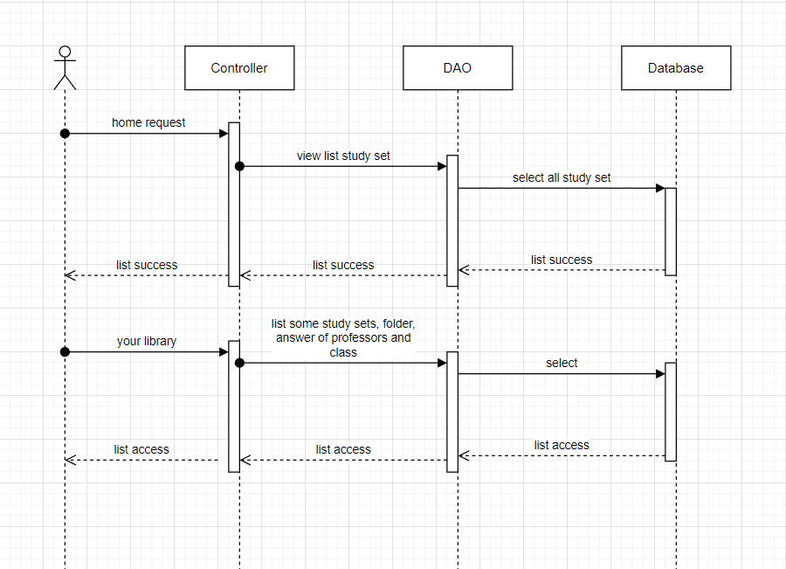

### d. Database Queries

*String sql = "Select * from StudySet";*

*String sql = "select top 5 * from StudySet where userId = ? order by studySetId desc";*

*String sql = "select top 5 * from Folder where userId = ? order by folderId desc ";*

## 14.Class set

### a. Class Diagram

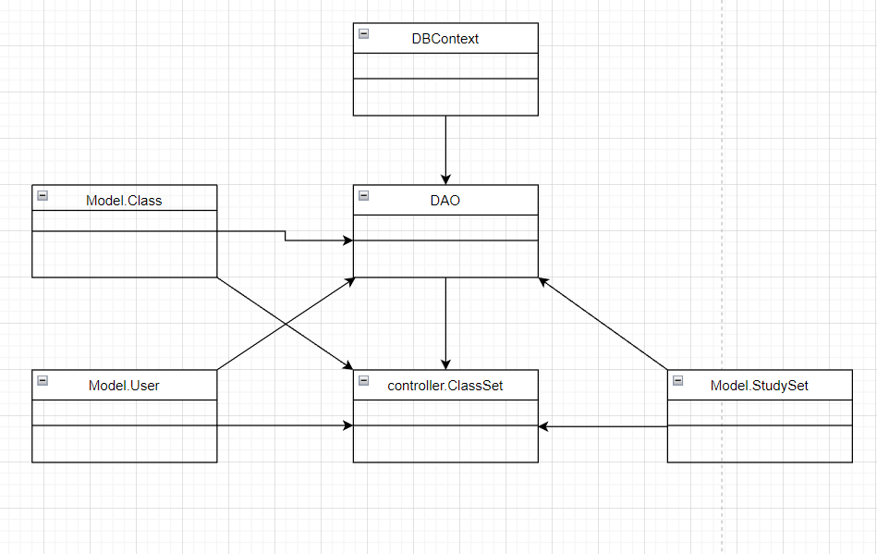

### b. Class Specifications

### User Class

|  |  |  |
| --- | --- | --- |
| **No** | **Method** | **Description** |
| *01* | *User(){}* | Default constructor |
| *02* | *User(….){}* | *Parameterized constructor* |
| *03* | *getName(){}* | *Getter of Name* |
| *04* | *setName(string name){}* | *Setter of Name* |
| *05* | *getPass(){}* | *Getter of Pass* |
| *06* | *setPass(string pass){}* | *Setter of Pass* |
| *07* | *getEmail(){}* | *Getter email* |
| *08* | *setEmail(string email){}* | *Setter of email* |
| *09* | *isIsActive(){}* | *Getter of isActive* |
| *10* | *setIsActive(Boolean isActive){}* | *Setter of isActive* |
| *11* | *getAvatar(){}* | *Getter of avatar* |
| *12* | *setAvatar(string avatar)* | *Setter of avatar* |
| *13* | *getLanguage(){}* | *Getter of language* |
| *14* | *setLanguage(string language){}* | *Setter of language* |

#### DBContext Class

|  |  |  |
| --- | --- | --- |
| **No** | **Method** | **Description** |
| *01* | *DBContext(){}* | *Connect to database* |

#### ClassSet controller Class

|  |  |  |
| --- | --- | --- |
| **No** | **Method** | **Description** |
| *01* | *doGet(){}* | *List information of class and information of study sets in class* |

#### DAO Class

|  |  |  |
| --- | --- | --- |
| **No** | **Method** | **Description** |
| *01* | *getListStudySetbyClassId(int id){}* | *Get all study set in a class* |
| *02* | *getClassByClassID(int id){}* | *Get class by class id* |
| *03* | *getAllStudySet(){}* | *Get all study set* |

#### StudySet Class

|  |  |  |
| --- | --- | --- |
| **No** | **Method** | **Description** |
| *01* | *StudySet() {)* | *Default Constructor* |
| *02* | *StudySet(){.....}* | *Parameterized constructor* |
| *03* | *getId(){}* | *getter of StudySetId* |
| *04* | *setId(int id){}* | *setter of StudySetId* |
| *05* | *getTitle(){}* | *getter of Title* |
| *06* | *setTitle(string title){}* | *setter of Title* |
| *07* | *getDescription(){}* | *getter of Description* |
| *08* | *setDescription(string Description){}* | *setter of Description* |
| *09* | *isIsShare() {}* | *getter of isShare* |
| *10* | *setIsShare(boolean isShare) { }* | *setter of isShare* |
| *11* | *getUserId() { }* | *getter of UserId* |
| *12* | *setUserId(int userId) { }* | *setter of UserId* |
| *13* | *getNumberCard() {}* | *get number flashcard in studyset* |
| *14* | *String getAuthor() {}* | *get name of User created studyset* |

### 

### Class Class

|  |  |  |
| --- | --- | --- |
| **No** | **Method** | **Description** |
| *01* | *Class() {)* | *Default Constructor* |
| *02* | *Class(){.....}* | *Parameterized constructor* |
| *03* | *getId(){}* | *getter of Class Id* |
| *04* | *setId(int id){}* | *setter of Class Id* |
| *05* | *getName(){}* | *getter of Class Name* |
| *06* | *setName(string name){}* | *setter of Class Name* |
| *07* | *getDesc(){}* | *getter of Desc* |
| *08* | *setDesc(string Desc){}* | *setter of Desc* |
| *09* | *getUserId() { }* | *getter of UserId* |
| *10* | *setUserId(int UserId) { }* | *setter of UserId* |
| *11* | *isIsInvite() {}* | *getter of isInvite* |
| *12* | *setIsInvite(boolean isInvite) { }* | *setter of isInvite* |
| *13* | *isIsEdit() {}* | *getter of isEdit* |
| *14* | *setIsEdit(boolean isEdit) { }* | *setter of isEdit* |
| *15* | *getInviteCode() {}* | *getter of inviteCode* |
| *16* | *setInviteCode(string inviteCode) { }* | *setter of inviteCode* |
| *17* | *getSchoolName() {}* | *getter of schoolName* |
| *18* | *setSchoolName(string inviteCode) { }* | *setter of schoolName* |

### 

### c. Sequence Diagram(s)

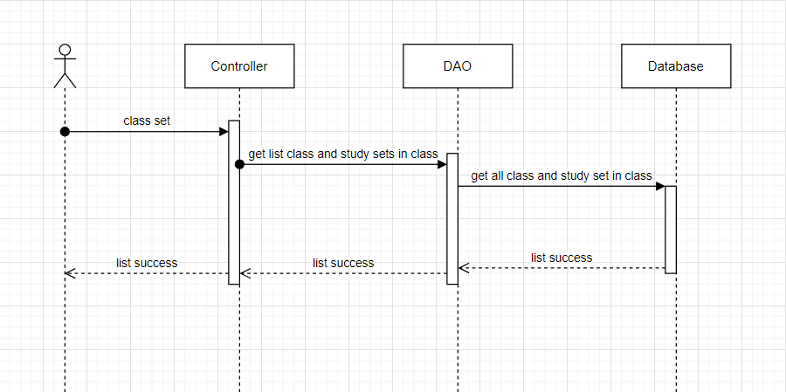

### d. Database Queries

*String sql = "select*from [Class] where classId=?";*

*String sql = "Select * from StudySet";*

## 15.Folder set

### a. Class Diagram

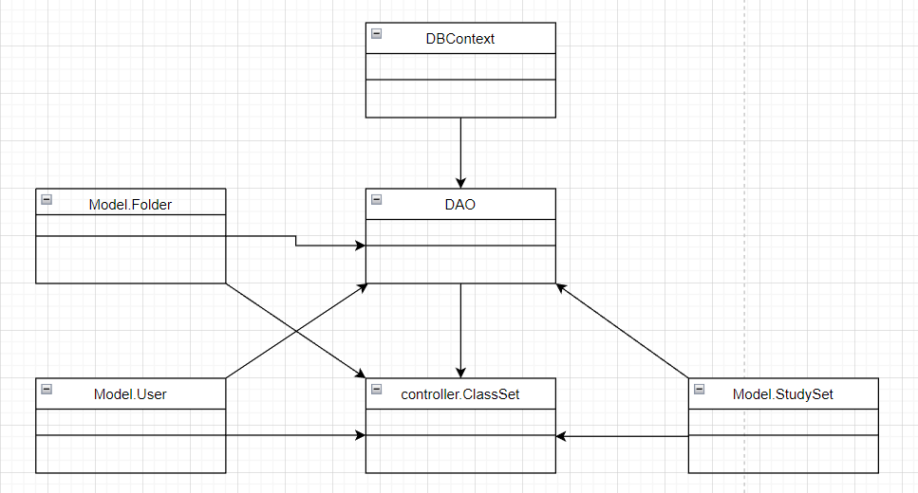

### b. Class Specifications

### User Class

|  |  |  |
| --- | --- | --- |
| **No** | **Method** | **Description** |
| *01* | *User(){}* | Default constructor |
| *02* | *User(….){}* | *Parameterized constructor* |
| *03* | *getName(){}* | *Getter of Name* |
| *04* | *setName(string name){}* | *Setter of Name* |
| *05* | *getPass(){}* | *Getter of Pass* |
| *06* | *setPass(string pass){}* | *Setter of Pass* |
| *07* | *getEmail(){}* | *Getter email* |
| *08* | *setEmail(string email){}* | *Setter of email* |
| *09* | *isIsActive(){}* | *Getter of isActive* |
| *10* | *setIsActive(Boolean isActive){}* | *Setter of isActive* |
| *11* | *getAvatar(){}* | *Getter of avatar* |
| *12* | *setAvatar(string avatar)* | *Setter of avatar* |
| *13* | *getLanguage(){}* | *Getter of language* |
| *14* | *setLanguage(string language){}* | *Setter of language* |

#### DBContext Class

|  |  |  |
| --- | --- | --- |
| **No** | **Method** | **Description** |
| *01* | *DBContext(){}* | *Connect to database* |

#### FolderSet controller Class

|  |  |  |
| --- | --- | --- |
| **No** | **Method** | **Description** |
| *01* | *doGet(){}* | *Get List study set* |
| *02* | *doPost(){}* | *Delete folder and study set in folder* |

#### DAO Class

|  |  |  |
| --- | --- | --- |
| **No** | **Method** | **Description** |
| *01* | *getListStudySet(int id){}* | *Get list study set and card in study set* |
| *02* | *getFolderByFolderId(int id){}* | *Get folder by folder id* |
| *03* | *getAllStudySet()* | *Get info of study set* |
| *04* | *removeListFolder(int id){}* | *Get remove list folder* |
| *05* | *deleteFolderByFolderId(int id){}* | *Delete folder by folder id* |

#### StudySet Class

|  |  |  |
| --- | --- | --- |
| **No** | **Method** | **Description** |
| *01* | *StudySet() {)* | *Default Constructor* |
| *02* | *StudySet(){.....}* | *Parameterized constructor* |
| *03* | *getId(){}* | *getter of StudySetId* |
| *04* | *setId(int id){}* | *setter of StudySetId* |
| *05* | *getTitle(){}* | *getter of Title* |
| *06* | *setTitle(string title){}* | *setter of Title* |
| *07* | *getDescription(){}* | *getter of Description* |
| *08* | *setDescription(string Description){}* | *setter of Description* |
| *09* | *isIsShare() {}* | *getter of isShare* |
| *10* | *setIsShare(boolean isShare) { }* | *setter of isShare* |
| *11* | *getUserId() { }* | *getter of UserId* |
| *12* | *setUserId(int userId) { }* | *setter of UserId* |
| *13* | *getNumberCard() {}* | *get number flashcard in studyset* |
| *14* | *String getAuthor() {}* | *get name of User created studyset* |

### 

### Folder Class

|  |  |  |
| --- | --- | --- |
| **No** | **Method** | **Description** |
| *01* | *Folder() {)* | *Default Constructor* |
| *02* | *Folder(){.....}* | *Parameterized constructor* |
| *03* | *getId(){}* | *getter of CardId* |
| *04* | *setId(int id){}* | *setter of CardId* |
| *05* | *getTitle(){}* | *getter of Title* |
| *06* | *setTitle(string term){}* | *setter of Title* |
| *07* | *getDescription(){}* | *getter of Description* |
| *08* | *setDescription(string Definition){}* | *setter of Description* |
| *09* | *getUserId() { }* | *getter of UserId* |
| *10* | *setUserId(int UserId) { }* | *setter of UserId* |

### 

### 

### 

### 

### 

### 

### 

### c. Sequence Diagram(s)

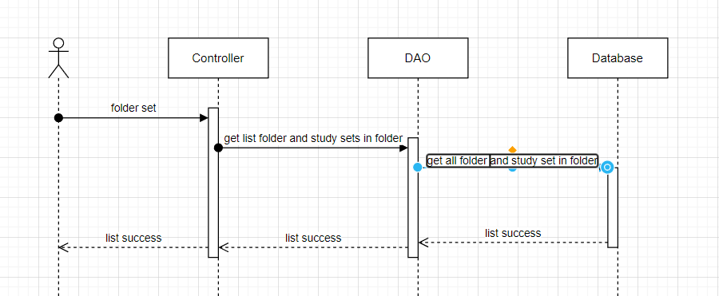

### d. Database Queries

*String sql = "select * from [Folder] where folderId =? ";*

*String sql = "Select * from StudySet";*

## 16.Study set list (wait)

### a. Class Diagram

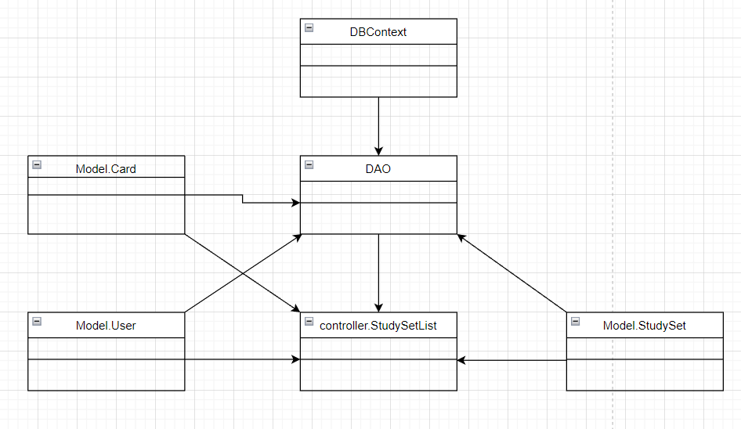

### b. Class Specifications

### User Class

|  |  |  |
| --- | --- | --- |
| **No** | **Method** | **Description** |
| *01* | *User(){}* | Default constructor |
| *02* | *User(….){}* | *Parameterized constructor* |
| *03* | *getName(){}* | *Getter of Name* |
| *04* | *setName(string name){}* | *Setter of Name* |
| *05* | *getPass(){}* | *Getter of Pass* |
| *06* | *setPass(string pass){}* | *Setter of Pass* |
| *07* | *getEmail(){}* | *Getter email* |
| *08* | *setEmail(string email){}* | *Setter of email* |
| *09* | *isIsActive(){}* | *Getter of isActive* |
| *10* | *setIsActive(Boolean isActive){}* | *Setter of isActive* |
| *11* | *getAvatar(){}* | *Getter of avatar* |
| *12* | *setAvatar(string avatar)* | *Setter of avatar* |
| *13* | *getLanguage(){}* | *Getter of language* |
| *14* | *setLanguage(string language){}* | *Setter of language* |

#### DBContext Class

|  |  |  |
| --- | --- | --- |
| **No** | **Method** | **Description** |
| *01* | *DBContext(){}* | *Connect to database* |

#### Verify controller Class

|  |  |  |
| --- | --- | --- |
| **No** | **Method** | **Description** |
| *01* | *doGet(){}* | *Send redirect to verify.jsp* |
| *02* | *doPost(){}* | *Active account by verify code* |

#### DAO Class

|  |  |  |
| --- | --- | --- |
| **No** | **Method** | **Description** |
| *01* | *Active account(string email){}* | *Update is active in database* |

#### StudySet Class

|  |  |  |
| --- | --- | --- |
| **No** | **Method** | **Description** |
| *01* | *StudySet() {)* | *Default Constructor* |
| *02* | *StudySet(){.....}* | *Parameterized constructor* |
| *03* | *getId(){}* | *getter of StudySetId* |
| *04* | *setId(int id){}* | *setter of StudySetId* |
| *05* | *getTitle(){}* | *getter of Title* |
| *06* | *setTitle(string title){}* | *setter of Title* |
| *07* | *getDescription(){}* | *getter of Description* |
| *08* | *setDescription(string Description){}* | *setter of Description* |
| *09* | *isIsShare() {}* | *getter of isShare* |
| *10* | *setIsShare(boolean isShare) { }* | *setter of isShare* |
| *11* | *getUserId() { }* | *getter of UserId* |
| *12* | *setUserId(int userId) { }* | *setter of UserId* |
| *13* | *getNumberCard() {}* | *get number flashcard in studyset* |
| *14* | *String getAuthor() {}* | *get name of User created studyset* |

### 

### 

### Folder Class

|  |  |  |
| --- | --- | --- |
| **No** | **Method** | **Description** |
| *01* | *Folder() {)* | *Default Constructor* |
| *02* | *Folder(){.....}* | *Parameterized constructor* |
| *03* | *getId(){}* | *getter of CardId* |
| *04* | *setId(int id){}* | *setter of CardId* |
| *05* | *getTitle(){}* | *getter of Title* |
| *06* | *setTitle(string term){}* | *setter of Title* |
| *07* | *getDescription(){}* | *getter of Description* |
| *08* | *setDescription(string Definition){}* | *setter of Description* |
| *09* | *getUserId() { }* | *getter of UserId* |
| *10* | *setUserId(int UserId) { }* | *setter of UserId* |

### 

### 

### 

### Class Class

|  |  |  |
| --- | --- | --- |
| **No** | **Method** | **Description** |
| *01* | *Class() {)* | *Default Constructor* |
| *02* | *Class(){.....}* | *Parameterized constructor* |
| *03* | *getId(){}* | *getter of Class Id* |
| *04* | *setId(int id){}* | *setter of Class Id* |
| *05* | *getName(){}* | *getter of Class Name* |
| *06* | *setName(string name){}* | *setter of Class Name* |
| *07* | *getDesc(){}* | *getter of Desc* |
| *08* | *setDesc(string Desc){}* | *setter of Desc* |
| *09* | *getUserId() { }* | *getter of UserId* |
| *10* | *setUserId(int UserId) { }* | *setter of UserId* |
| *11* | *isIsInvite() {}* | *getter of isInvite* |
| *12* | *setIsInvite(boolean isInvite) { }* | *setter of isInvite* |
| *13* | *isIsEdit() {}* | *getter of isEdit* |
| *14* | *setIsEdit(boolean isEdit) { }* | *setter of isEdit* |
| *15* | *getInviteCode() {}* | *getter of inviteCode* |
| *16* | *setInviteCode(string inviteCode) { }* | *setter of inviteCode* |
| *17* | *getSchoolName() {}* | *getter of schoolName* |
| *18* | *setSchoolName(string inviteCode) { }* | *setter of schoolName* |

### 

### 

### 

### Card Class

|  |  |  |
| --- | --- | --- |
| **No** | **Method** | **Description** |
| *01* | *Card() {)* | *Default Constructor* |
| *02* | *Card(){.....}* | *Parameterized constructor* |
| *03* | *getId(){}* | *getter of CardId* |
| *04* | *setId(int id){}* | *setter of CardId* |
| *05* | *getTerm(){}* | *getter of Term* |
| *06* | *setTerm(string term){}* | *setter of Term* |
| *07* | *getDefinition(){}* | *getter of Definition* |
| *08* | *setDefinition(string Definition){}* | *setter of Definition* |
| *09* | *getStudySetId() { }* | *getter of StudySetId* |
| *10* | *setStudySetId(int studySetId) { }* | *setter of StudySetId* |

### 

### 

### 

### 

### 

### 

### 

### 

### 

### c. Sequence Diagram(s)

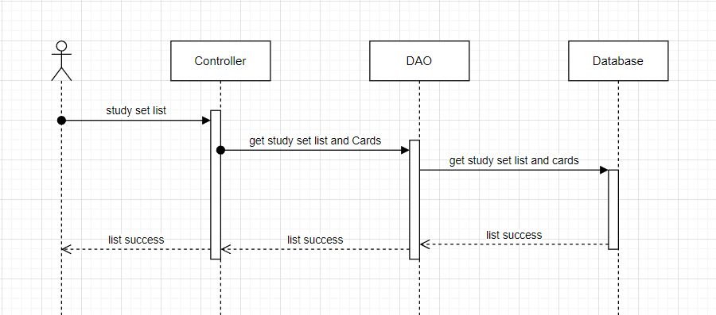

### d. Database Queries

*String sql = "UPDATE [User]\n"*

*+ "SET\n"*

*+ "\n"*

*+ "password = ?\n"*

*+ "\n"*

*+ "WHERE userId = ?";*

## 17.Controller folder set

### a. Class Diagram

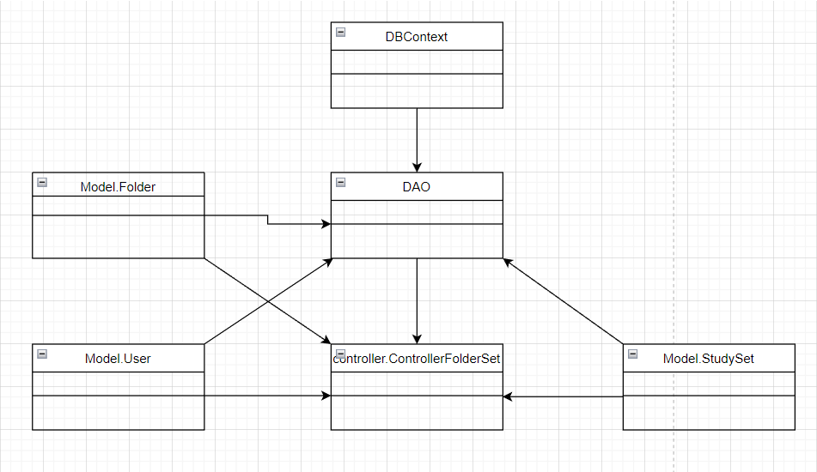

### b. Class Specifications

### User Class

|  |  |  |
| --- | --- | --- |
| **No** | **Method** | **Description** |
| *01* | *User(){}* | Default constructor |
| *02* | *User(….){}* | *Parameterized constructor* |
| *03* | *getName(){}* | *Getter of Name* |
| *04* | *setName(string name){}* | *Setter of Name* |
| *05* | *getPass(){}* | *Getter of Pass* |
| *06* | *setPass(string pass){}* | *Setter of Pass* |
| *07* | *getEmail(){}* | *Getter email* |
| *08* | *setEmail(string email){}* | *Setter of email* |
| *09* | *isIsActive(){}* | *Getter of isActive* |
| *10* | *setIsActive(Boolean isActive){}* | *Setter of isActive* |
| *11* | *getAvatar(){}* | *Getter of avatar* |
| *12* | *setAvatar(string avatar)* | *Setter of avatar* |
| *13* | *getLanguage(){}* | *Getter of language* |
| *14* | *setLanguage(string language){}* | *Setter of language* |

#### DBContext Class

|  |  |  |
| --- | --- | --- |
| **No** | **Method** | **Description** |
| *01* | *DBContext(){}* | *Connect to database* |

#### ControllerFolderSet controller Class

|  |  |  |
| --- | --- | --- |
| **No** | **Method** | **Description** |
| *01* | *doGet(){}* | *Delete or add new study set to folder set* |

#### DAO Class

|  |  |  |
| --- | --- | --- |
| **No** | **Method** | **Description** |
| *01* | *deleteStudySetInFolder(int fid, int sid){}* | *Delete study set from folder* |
| *02* | *addStudySetInFolder(int fid, int sid){}* | *Add new study set to folder* |

#### StudySet Class

|  |  |  |
| --- | --- | --- |
| **No** | **Method** | **Description** |
| *01* | *StudySet() {)* | *Default Constructor* |
| *02* | *StudySet(){.....}* | *Parameterized constructor* |
| *03* | *getId(){}* | *getter of StudySetId* |
| *04* | *setId(int id){}* | *setter of StudySetId* |
| *05* | *getTitle(){}* | *getter of Title* |
| *06* | *setTitle(string title){}* | *setter of Title* |
| *07* | *getDescription(){}* | *getter of Description* |
| *08* | *setDescription(string Description){}* | *setter of Description* |
| *09* | *isIsShare() {}* | *getter of isShare* |
| *10* | *setIsShare(boolean isShare) { }* | *setter of isShare* |
| *11* | *getUserId() { }* | *getter of UserId* |
| *12* | *setUserId(int userId) { }* | *setter of UserId* |
| *13* | *getNumberCard() {}* | *get number flashcard in studyset* |
| *14* | *String getAuthor() {}* | *get name of User created studyset* |

### 

### 

### Folder Class

|  |  |  |
| --- | --- | --- |
| **No** | **Method** | **Description** |
| *01* | *Folder() {)* | *Default Constructor* |
| *02* | *Folder(){.....}* | *Parameterized constructor* |
| *03* | *getId(){}* | *getter of CardId* |
| *04* | *setId(int id){}* | *setter of CardId* |
| *05* | *getTitle(){}* | *getter of Title* |
| *06* | *setTitle(string term){}* | *setter of Title* |
| *07* | *getDescription(){}* | *getter of Description* |
| *08* | *setDescription(string Definition){}* | *setter of Description* |
| *09* | *getUserId() { }* | *getter of UserId* |
| *10* | *setUserId(int UserId) { }* | *setter of UserId* |

### 

### 

### 

### 

### 

### 

### 

### c. Sequence Diagram(s)

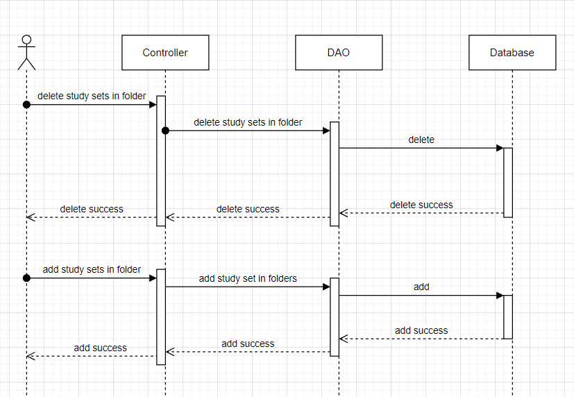

### d. Database Queries

*String sql = "DELETE FROM [dbo].[ListFolder]\n"*

*+ " WHERE studySetId=? and folderId=?";*

*String sql = "INSERT INTO [dbo].[ListFolder]\n"*

*+ " ([studySetId]\n"*

*+ " ,[folderId])\n"*

*+ " VALUES (?, ?)";*

## 18.Controller class set

### a. Class Diagram

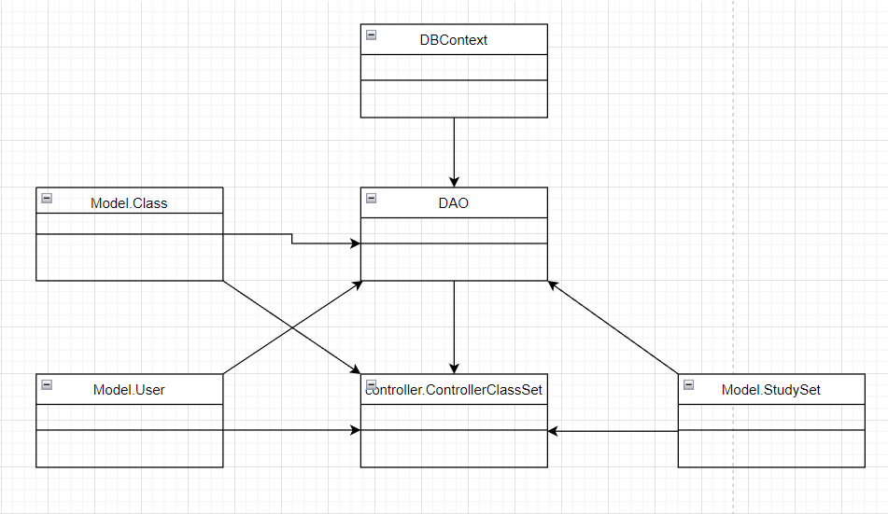

### b. Class Specifications

### User Class

|  |  |  |
| --- | --- | --- |
| **No** | **Method** | **Description** |
| *01* | *User(){}* | Default constructor |
| *02* | *User(….){}* | *Parameterized constructor* |
| *03* | *getName(){}* | *Getter of Name* |
| *04* | *setName(string name){}* | *Setter of Name* |
| *05* | *getPass(){}* | *Getter of Pass* |
| *06* | *setPass(string pass){}* | *Setter of Pass* |
| *07* | *getEmail(){}* | *Getter email* |
| *08* | *setEmail(string email){}* | *Setter of email* |
| *09* | *isIsActive(){}* | *Getter of isActive* |
| *10* | *setIsActive(Boolean isActive){}* | *Setter of isActive* |
| *11* | *getAvatar(){}* | *Getter of avatar* |
| *12* | *setAvatar(string avatar)* | *Setter of avatar* |
| *13* | *getLanguage(){}* | *Getter of language* |
| *14* | *setLanguage(string language){}* | *Setter of language* |

#### DBContext Class

|  |  |  |
| --- | --- | --- |
| **No** | **Method** | **Description** |
| *01* | *DBContext(){}* | *Connect to database* |

#### Controller Class Set Class

|  |  |  |
| --- | --- | --- |
| **No** | **Method** | **Description** |
| *01* | *doGet(){}* | *Delete or add study set in class* |

|  |  |  |
| --- | --- | --- |
| **No** | **Method** | **Description** |
| *01* | *deleteStudySetInClass(int cid, int sid){}* | *Delete study set from class* |
| *02* | *addStudySetInClass(int cid, int sid){}* | *Add new study set to class* |

#### StudySet Class

|  |  |  |
| --- | --- | --- |
| **No** | **Method** | **Description** |
| *01* | *StudySet() {)* | *Default Constructor* |
| *02* | *StudySet(){.....}* | *Parameterized constructor* |
| *03* | *getId(){}* | *getter of StudySetId* |
| *04* | *setId(int id){}* | *setter of StudySetId* |
| *05* | *getTitle(){}* | *getter of Title* |
| *06* | *setTitle(string title){}* | *setter of Title* |
| *07* | *getDescription(){}* | *getter of Description* |
| *08* | *setDescription(string Description){}* | *setter of Description* |
| *09* | *isIsShare() {}* | *getter of isShare* |
| *10* | *setIsShare(boolean isShare) { }* | *setter of isShare* |
| *11* | *getUserId() { }* | *getter of UserId* |
| *12* | *setUserId(int userId) { }* | *setter of UserId* |
| *13* | *getNumberCard() {}* | *get number flashcard in studyset* |
| *14* | *String getAuthor() {}* | *get name of User created studyset* |

### 

### 

### 

### 

### 

### Class Class

|  |  |  |
| --- | --- | --- |
| **No** | **Method** | **Description** |
| *01* | *Class() {)* | *Default Constructor* |
| *02* | *Class(){.....}* | *Parameterized constructor* |
| *03* | *getId(){}* | *getter of Class Id* |
| *04* | *setId(int id){}* | *setter of Class Id* |
| *05* | *getName(){}* | *getter of Class Name* |
| *06* | *setName(string name){}* | *setter of Class Name* |
| *07* | *getDesc(){}* | *getter of Desc* |
| *08* | *setDesc(string Desc){}* | *setter of Desc* |
| *09* | *getUserId() { }* | *getter of UserId* |
| *10* | *setUserId(int UserId) { }* | *setter of UserId* |
| *11* | *isIsInvite() {}* | *getter of isInvite* |
| *12* | *setIsInvite(boolean isInvite) { }* | *setter of isInvite* |
| *13* | *isIsEdit() {}* | *getter of isEdit* |
| *14* | *setIsEdit(boolean isEdit) { }* | *setter of isEdit* |
| *15* | *getInviteCode() {}* | *getter of inviteCode* |
| *16* | *setInviteCode(string inviteCode) { }* | *setter of inviteCode* |
| *17* | *getSchoolName() {}* | *getter of schoolName* |
| *18* | *setSchoolName(string inviteCode) { }* | *setter of schoolName* |

### 

### 

### 

### 

### c. Sequence Diagram(s)

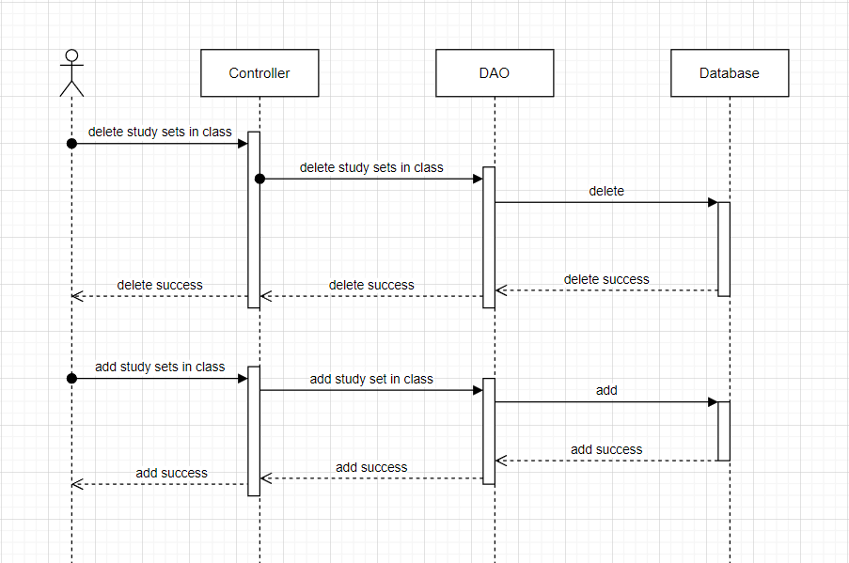

### d. Database Queries

*String sql = "DELETE FROM [dbo].[ListStudySet]\n"*

*+ " WHERE studySetId=? and classId=?";*

*String sql = "INSERT INTO [dbo].[ListStudySet]\n"*

*+ " ([studySetId]\n"*

*+ " ,[classId])\n"*

*+ " VALUES (?, ?)";*

## 19. Create class

### a. Class Diagram

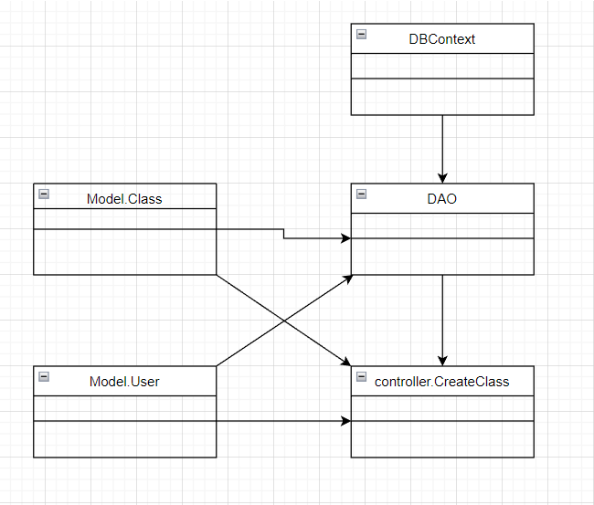

### b. Class Specifications

### User Class

|  |  |  |
| --- | --- | --- |
| **No** | **Method** | **Description** |
| *01* | *User(){}* | Default constructor |
| *02* | *User(….){}* | *Parameterized constructor* |
| *03* | *getName(){}* | *Getter of Name* |
| *04* | *setName(string name){}* | *Setter of Name* |
| *05* | *getPass(){}* | *Getter of Pass* |
| *06* | *setPass(string pass){}* | *Setter of Pass* |
| *07* | *getEmail(){}* | *Getter email* |
| *08* | *setEmail(string email){}* | *Setter of email* |
| *09* | *isIsActive(){}* | *Getter of isActive* |
| *10* | *setIsActive(Boolean isActive){}* | *Setter of isActive* |
| *11* | *getAvatar(){}* | *Getter of avatar* |
| *12* | *setAvatar(string avatar)* | *Setter of avatar* |
| *13* | *getLanguage(){}* | *Getter of language* |
| *14* | *setLanguage(string language){}* | *Setter of language* |

#### DBContext Class

|  |  |  |
| --- | --- | --- |
| **No** | **Method** | **Description** |
| *01* | *DBContext(){}* | *Connect to database* |

#### CreateClass controller Class

|  |  |  |
| --- | --- | --- |
| **No** | **Method** | **Description** |
| *01* | *doGet(){}* | *List some class* |
| *02* | *doPost(){}* | *Create new class* |

#### DAO Class

|  |  |  |
| --- | --- | --- |
| **No** | **Method** | **Description** |
| *01* | *getAllClass(){}* | *Get all class in database* |
| *02* | *createClass(class c)* | *Create a new class* |

### 

### 

### 

### 

### 

### Class Class

|  |  |  |
| --- | --- | --- |
| **No** | **Method** | **Description** |
| *01* | *Class() {)* | *Default Constructor* |
| *02* | *Class(){.....}* | *Parameterized constructor* |
| *03* | *getId(){}* | *getter of Class Id* |
| *04* | *setId(int id){}* | *setter of Class Id* |
| *05* | *getName(){}* | *getter of Class Name* |
| *06* | *setName(string name){}* | *setter of Class Name* |
| *07* | *getDesc(){}* | *getter of Desc* |
| *08* | *setDesc(string Desc){}* | *setter of Desc* |
| *09* | *getUserId() { }* | *getter of UserId* |
| *10* | *setUserId(int UserId) { }* | *setter of UserId* |
| *11* | *isIsInvite() {}* | *getter of isInvite* |
| *12* | *setIsInvite(boolean isInvite) { }* | *setter of isInvite* |
| *13* | *isIsEdit() {}* | *getter of isEdit* |
| *14* | *setIsEdit(boolean isEdit) { }* | *setter of isEdit* |
| *15* | *getInviteCode() {}* | *getter of inviteCode* |
| *16* | *setInviteCode(string inviteCode) { }* | *setter of inviteCode* |
| *17* | *getSchoolName() {}* | *getter of schoolName* |
| *18* | *setSchoolName(string inviteCode) { }* | *setter of schoolName* |

### 

### 

### 

### 

### c. Sequence Diagram(s)

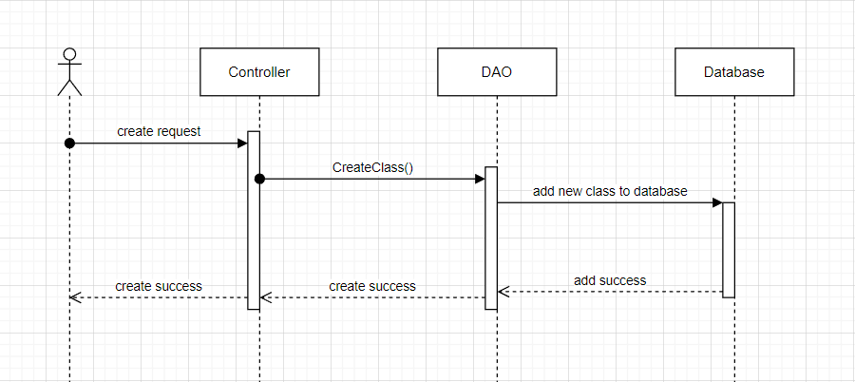

### d. Database Queries

*String sql = "INSERT INTO [dbo].[Class]\n"*

*+ " ([className]\n"*

*+ " ,[description]\n"*

*+ " ,[isInvite]\n"*

*+ " ,[inviteCode]\n"*

*+ " ,[isEdit]\n"*

*+ " ,[schoolName]\n"*

*+ " ,[userId])\n"*

*+ " VALUES\n"*

*+ " (?\n"*

*+ " ,? \n"*

*+ " ,? \n"*

*+ " ,?\n"*

*+ " ,?\n"*

*+ " ,?\n"*

*+ " ,?)";*

## 20. Create folder

### a. Class Diagram

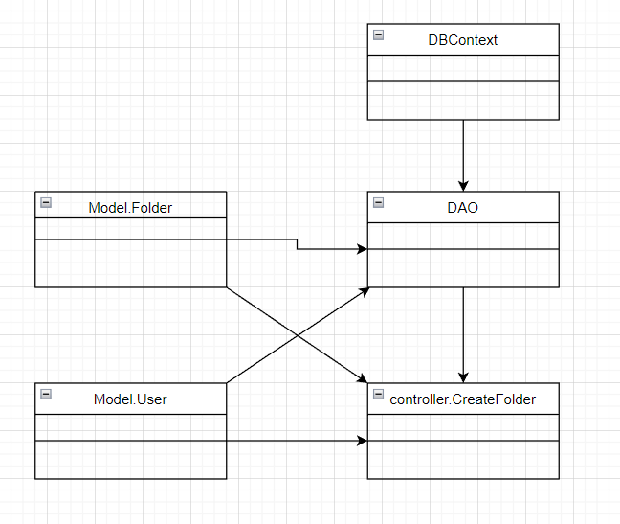

### b. Class Specifications

### User Class

|  |  |  |
| --- | --- | --- |
| **No** | **Method** | **Description** |
| *01* | *User(){}* | Default constructor |
| *02* | *User(….){}* | *Parameterized constructor* |
| *03* | *getName(){}* | *Getter of Name* |
| *04* | *setName(string name){}* | *Setter of Name* |
| *05* | *getPass(){}* | *Getter of Pass* |
| *06* | *setPass(string pass){}* | *Setter of Pass* |
| *07* | *getEmail(){}* | *Getter email* |
| *08* | *setEmail(string email){}* | *Setter of email* |
| *09* | *isIsActive(){}* | *Getter of isActive* |
| *10* | *setIsActive(Boolean isActive){}* | *Setter of isActive* |
| *11* | *getAvatar(){}* | *Getter of avatar* |
| *12* | *setAvatar(string avatar)* | *Setter of avatar* |
| *13* | *getLanguage(){}* | *Getter of language* |
| *14* | *setLanguage(string language){}* | *Setter of language* |

#### DBContext Class

|  |  |  |
| --- | --- | --- |
| **No** | **Method** | **Description** |
| *01* | *DBContext(){}* | *Connect to database* |

#### CreateFolder controller Class

|  |  |  |
| --- | --- | --- |
| **No** | **Method** | **Description** |
| *01* | *doGet(){}* | *List all folder by user id* |
| *02* | *doPost(){}* | *Create new folder* |

#### DAO Class

|  |  |  |
| --- | --- | --- |
| **No** | **Method** | **Description** |
| *01* | *getAllFolderByUserId(int id){}* | *Get all folder by user id after creating* |
| *02* | *CreateFolder(Folder f){}* | *Create a new folder* |

### 

### 

### Folder Class

|  |  |  |
| --- | --- | --- |
| **No** | **Method** | **Description** |
| *01* | *Folder() {)* | *Default Constructor* |
| *02* | *Folder(){.....}* | *Parameterized constructor* |
| *03* | *getId(){}* | *getter of CardId* |
| *04* | *setId(int id){}* | *setter of CardId* |
| *05* | *getTitle(){}* | *getter of Title* |
| *06* | *setTitle(string term){}* | *setter of Title* |
| *07* | *getDescription(){}* | *getter of Description* |
| *08* | *setDescription(string Definition){}* | *setter of Description* |
| *09* | *getUserId() { }* | *getter of UserId* |
| *10* | *setUserId(int UserId) { }* | *setter of UserId* |

### 

### 

### 

### 

### 

### 

### 

### c. Sequence Diagram(s)

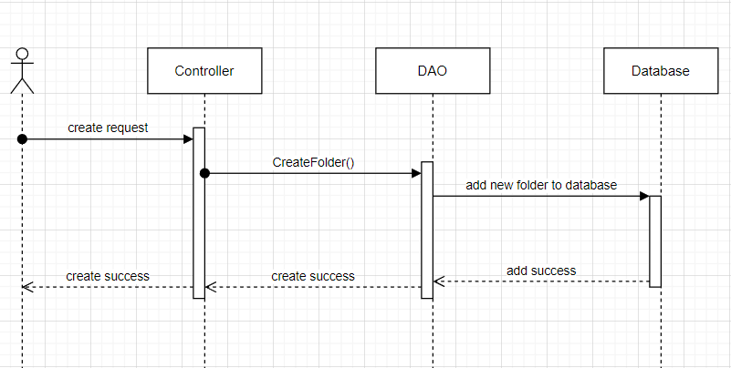

### d. Database Queries

*String sql = "INSERT INTO [dbo].[Folder]\n"*

*+ " ([title]\n"*

*+ " ,[description]\n"*

*+ " ,[userId]\n"*

*+ " ,[isShare])\n"*

*+ " VALUES\n"*

*+ " (?\n"*

*+ " ,?\n"*

*+ " ,?\n"*

*+ " ,?)";*

## 21. Reset studied Cards

### a. Class Diagram

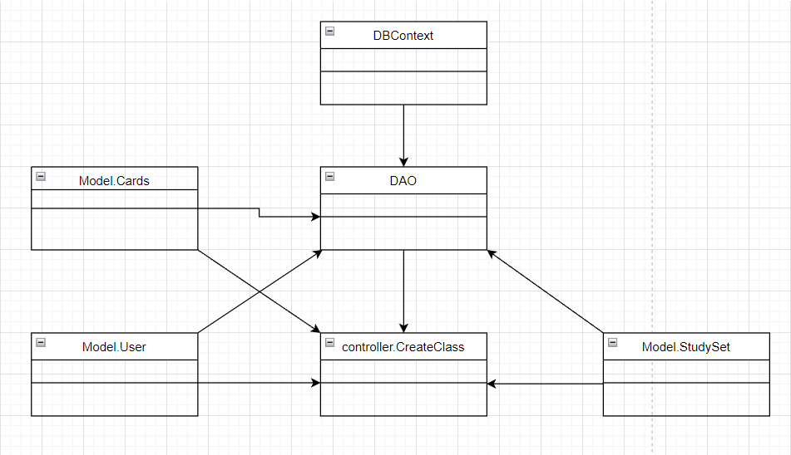

### b. Class Specifications

### User Class

|  |  |  |
| --- | --- | --- |
| **No** | **Method** | **Description** |
| *01* | *User(){}* | Default constructor |
| *02* | *User(….){}* | *Parameterized constructor* |
| *03* | *getName(){}* | *Getter of Name* |
| *04* | *setName(string name){}* | *Setter of Name* |
| *05* | *getPass(){}* | *Getter of Pass* |
| *06* | *setPass(string pass){}* | *Setter of Pass* |
| *07* | *getEmail(){}* | *Getter email* |
| *08* | *setEmail(string email){}* | *Setter of email* |
| *09* | *isIsActive(){}* | *Getter of isActive* |
| *10* | *setIsActive(Boolean isActive){}* | *Setter of isActive* |
| *11* | *getAvatar(){}* | *Getter of avatar* |
| *12* | *setAvatar(string avatar)* | *Setter of avatar* |
| *13* | *getLanguage(){}* | *Getter of language* |
| *14* | *setLanguage(string language){}* | *Setter of language* |

#### DBContext Class

|  |  |  |
| --- | --- | --- |
| **No** | **Method** | **Description** |
| *01* | *DBContext(){}* | *Connect to database* |

#### ResetStudiedCard controller Class

|  |  |  |
| --- | --- | --- |
| **No** | **Method** | **Description** |
| *01* | *doGet(){}* | *Reset studied cards in study set* |

#### DAO Class

|  |  |  |
| --- | --- | --- |
| **No** | **Method** | **Description** |
| *01* | *resetStudiedCard(int uid, int studysetId){}* | *Reset studied card to study again.* |

#### StudySet Class

|  |  |  |
| --- | --- | --- |
| **No** | **Method** | **Description** |
| *01* | *StudySet() {)* | *Default Constructor* |
| *02* | *StudySet(){.....}* | *Parameterized constructor* |
| *03* | *getId(){}* | *getter of StudySetId* |
| *04* | *setId(int id){}* | *setter of StudySetId* |
| *05* | *getTitle(){}* | *getter of Title* |
| *06* | *setTitle(string title){}* | *setter of Title* |
| *07* | *getDescription(){}* | *getter of Description* |
| *08* | *setDescription(string Description){}* | *setter of Description* |
| *09* | *isIsShare() {}* | *getter of isShare* |
| *10* | *setIsShare(boolean isShare) { }* | *setter of isShare* |
| *11* | *getUserId() { }* | *getter of UserId* |
| *12* | *setUserId(int userId) { }* | *setter of UserId* |
| *13* | *getNumberCard() {}* | *get number flashcard in studyset* |
| *14* | *String getAuthor() {}* | *get name of User created studyset* |

### 

### 

### 

### Card Class

|  |  |  |
| --- | --- | --- |
| **No** | **Method** | **Description** |
| *01* | *Card() {)* | *Default Constructor* |
| *02* | *Card(){.....}* | *Parameterized constructor* |
| *03* | *getId(){}* | *getter of CardId* |
| *04* | *setId(int id){}* | *setter of CardId* |
| *05* | *getTerm(){}* | *getter of Term* |
| *06* | *setTerm(string term){}* | *setter of Term* |
| *07* | *getDefinition(){}* | *getter of Definition* |
| *08* | *setDefinition(string Definition){}* | *setter of Definition* |
| *09* | *getStudySetId() { }* | *getter of StudySetId* |
| *10* | *setStudySetId(int studySetId) { }* | *setter of StudySetId* |

### 

### c. Sequence Diagram(s)

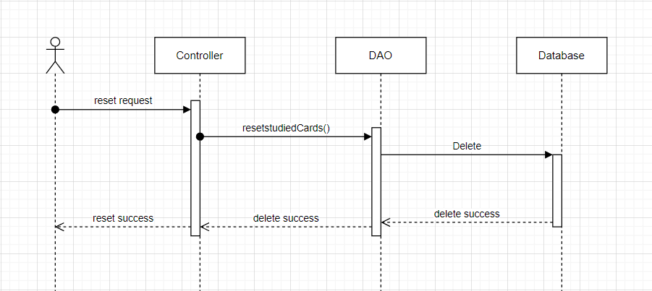

### d. Database Queries

*String sql = "DELETE FROM [dbo].[FlashCards]\n"*

*+ " WHERE userId=? and studySetId=?";*

## 22. Send email

### a. Class Diagram

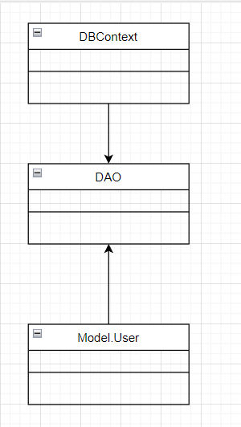

### b. Class Specifications

### User Class

|  |  |  |
| --- | --- | --- |
| **No** | **Method** | **Description** |
| *01* | *User(){}* | Default constructor |
| *02* | *User(….){}* | *Parameterized constructor* |
| *03* | *getName(){}* | *Getter of Name* |
| *04* | *setName(string name){}* | *Setter of Name* |
| *05* | *getPass(){}* | *Getter of Pass* |
| *06* | *setPass(string pass){}* | *Setter of Pass* |
| *07* | *getEmail(){}* | *Getter email* |
| *08* | *setEmail(string email){}* | *Setter of email* |
| *09* | *isIsActive(){}* | *Getter of isActive* |
| *10* | *setIsActive(Boolean isActive){}* | *Setter of isActive* |
| *11* | *getAvatar(){}* | *Getter of avatar* |
| *12* | *setAvatar(string avatar)* | *Setter of avatar* |
| *13* | *getLanguage(){}* | *Getter of language* |
| *14* | *setLanguage(string language){}* | *Setter of language* |

#### DBContext Class

|  |  |  |
| --- | --- | --- |
| **No** | **Method** | **Description** |
| *01* | *DBContext(){}* | *Connect to database* |

#### SendEmail Class

|  |  |  |
| --- | --- | --- |
| **No** | **Method** | **Description** |
| *01* | *getRandom(){}* | *Get a code 6 character reandom* |
| *02* | *sendEmail(user, code){}* | *Send code to email of user* |
| *03* | *sendEmailPass(id, to ,cid){}* | *Send link to change password to email* |

#### DAO Class

|  |  |  |
| --- | --- | --- |
| **No** | **Method** | **Description** |
| *01* | *Active account(string email){}* | *Update is active in database* |

### 

### 

### 

### 

### 

### 

### 

### 

### 

### c. Sequence Diagram(s)

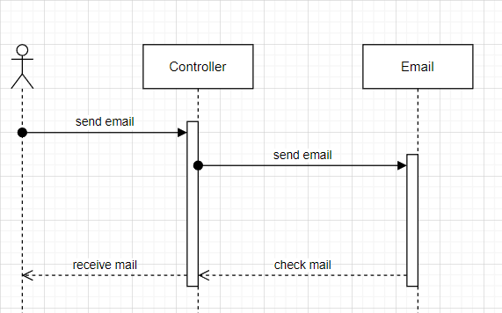

### d. Database Queries

*Send email function do not use database queries.*

## 23. Study

### a. Class Diagram

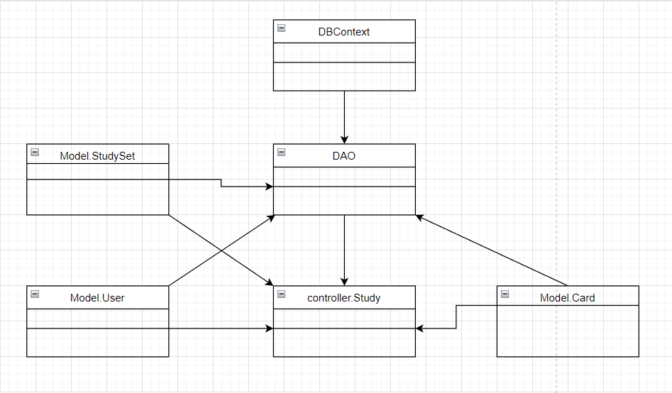

### b. Class Specifications

### User Class

|  |  |  |
| --- | --- | --- |
| **No** | **Method** | **Description** |
| *01* | *User(){}* | Default constructor |
| *02* | *User(….){}* | *Parameterized constructor* |
| *03* | *getName(){}* | *Getter of Name* |
| *04* | *setName(string name){}* | *Setter of Name* |
| *05* | *getPass(){}* | *Getter of Pass* |
| *06* | *setPass(string pass){}* | *Setter of Pass* |
| *07* | *getEmail(){}* | *Getter email* |
| *08* | *setEmail(string email){}* | *Setter of email* |
| *09* | *isIsActive(){}* | *Getter of isActive* |
| *10* | *setIsActive(Boolean isActive){}* | *Setter of isActive* |
| *11* | *getAvatar(){}* | *Getter of avatar* |
| *12* | *setAvatar(string avatar)* | *Setter of avatar* |
| *13* | *getLanguage(){}* | *Getter of language* |
| *14* | *setLanguage(string language){}* | *Setter of language* |

#### DBContext Class

|  |  |  |
| --- | --- | --- |
| **No** | **Method** | **Description** |
| *01* | *DBContext(){}* | *Connect to database* |

#### Study controller Class

|  |  |  |
| --- | --- | --- |
| **No** | **Method** | **Description** |
| *01* | *doGet(){}* | *Get all cards to test* |

#### DAO Class

|  |  |  |
| --- | --- | --- |
| **No** | **Method** | **Description** |
| *01* | *GetStudySetByID(int id){}* | *Get study set by id* |
| *02* | *ListCTF(int id, nit uid, int num){}* | *List cards true false* |
| *03* | *listATF(int id, int uid, int num){}* | *Get answer of cards* |
| *04* | *listCMC(int id, int uid, listCTF,int num){}* | *List card to multiple choice* |

#### StudySet Class

|  |  |  |
| --- | --- | --- |
| **No** | **Method** | **Description** |
| *01* | *StudySet() {)* | *Default Constructor* |
| *02* | *StudySet(){.....}* | *Parameterized constructor* |
| *03* | *getId(){}* | *getter of StudySetId* |
| *04* | *setId(int id){}* | *setter of StudySetId* |
| *05* | *getTitle(){}* | *getter of Title* |
| *06* | *setTitle(string title){}* | *setter of Title* |
| *07* | *getDescription(){}* | *getter of Description* |
| *08* | *setDescription(string Description){}* | *setter of Description* |
| *09* | *isIsShare() {}* | *getter of isShare* |
| *10* | *setIsShare(boolean isShare) { }* | *setter of isShare* |
| *11* | *getUserId() { }* | *getter of UserId* |
| *12* | *setUserId(int userId) { }* | *setter of UserId* |
| *13* | *getNumberCard() {}* | *get number flashcard in studyset* |
| *14* | *String getAuthor() {}* | *get name of User created studyset* |

### 

### 

### 

### 

### 

### 

### Card Class

|  |  |  |
| --- | --- | --- |
| **No** | **Method** | **Description** |
| *01* | *Card() {)* | *Default Constructor* |
| *02* | *Card(){.....}* | *Parameterized constructor* |
| *03* | *getId(){}* | *getter of CardId* |
| *04* | *setId(int id){}* | *setter of CardId* |
| *05* | *getTerm(){}* | *getter of Term* |
| *06* | *setTerm(string term){}* | *setter of Term* |
| *07* | *getDefinition(){}* | *getter of Definition* |
| *08* | *setDefinition(string Definition){}* | *setter of Definition* |
| *09* | *getStudySetId() { }* | *getter of StudySetId* |
| *10* | *setStudySetId(int studySetId) { }* | *setter of StudySetId* |

### 

### c. Sequence Diagram(s)

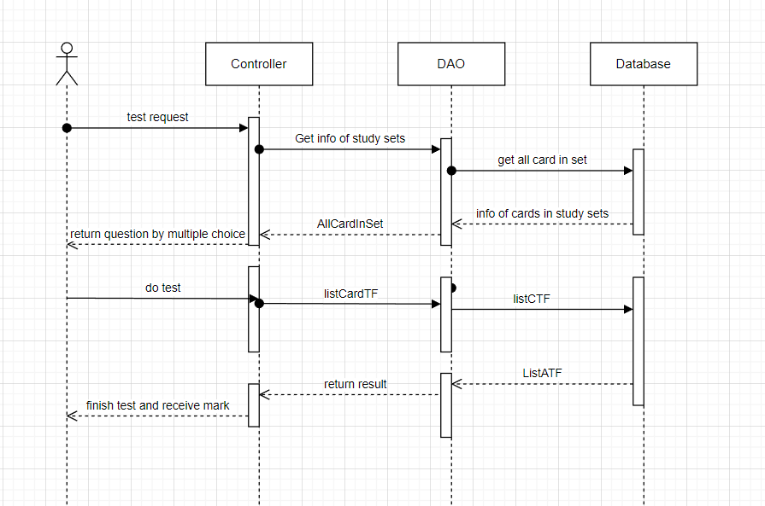

### d. Database Queries

*String sql = "SELECT [studySetId]\n"*

*+ " ,[title]\n"*

*+ " ,[description]\n"*

*+ " ,[isShare]\n"*

*+ " ,[userId]\n"*

*+ " FROM [dbo].[StudySet]\n"*

*+ " WHERE studySetId=?";*

*String sql = "SELECT [cardId]\n"*

*+ " ,[term]\n"*

*+ " ,[definition]\n"*

*+ " ,[studySetId]\n"*

*+ " FROM [dbo].[Card]\n"*

*+ " WHERE studySetID=?";*

*String sql = "SELECT [userId]\n"*

*+ " ,[cardId]\n"*

*+ " FROM [dbo].[FlashCards]"*

*+ " WHERE studySetId = ? and userId = ?";*

## 24. Test

### a. Class Diagram

**

### b. Class Specifications

### User Class

|  |  |  |
| --- | --- | --- |
| **No** | **Method** | **Description** |
| *01* | *User(){}* | Default constructor |
| *02* | *User(….){}* | *Parameterized constructor* |
| *03* | *getName(){}* | *Getter of Name* |
| *04* | *setName(string name){}* | *Setter of Name* |
| *05* | *getPass(){}* | *Getter of Pass* |
| *06* | *setPass(string pass){}* | *Setter of Pass* |
| *07* | *getEmail(){}* | *Getter email* |
| *08* | *setEmail(string email){}* | *Setter of email* |
| *09* | *isIsActive(){}* | *Getter of isActive* |
| *10* | *setIsActive(Boolean isActive){}* | *Setter of isActive* |
| *11* | *getAvatar(){}* | *Getter of avatar* |
| *12* | *setAvatar(string avatar)* | *Setter of avatar* |
| *13* | *getLanguage(){}* | *Getter of language* |
| *14* | *setLanguage(string language){}* | *Setter of language* |

#### DBContext Class

|  |  |  |
| --- | --- | --- |
| **No** | **Method** | **Description** |
| *01* | *DBContext(){}* | *Connect to database* |

#### Test controller Class

|  |  |  |
| --- | --- | --- |
| **No** | **Method** | **Description** |
| *01* | *doGet(){}* | *Get all Cards to study* |

#### DAO Class

|  |  |  |
| --- | --- | --- |
| **No** | **Method** | **Description** |
| *01* | *Active account(string email){}* | *Update is active in database* |

#### StudySet Class

|  |  |  |
| --- | --- | --- |
| **No** | **Method** | **Description** |
| *01* | *StudySet() {)* | *Default Constructor* |
| *02* | *StudySet(){.....}* | *Parameterized constructor* |
| *03* | *getId(){}* | *getter of StudySetId* |
| *04* | *setId(int id){}* | *setter of StudySetId* |
| *05* | *getTitle(){}* | *getter of Title* |
| *06* | *setTitle(string title){}* | *setter of Title* |
| *07* | *getDescription(){}* | *getter of Description* |
| *08* | *setDescription(string Description){}* | *setter of Description* |
| *09* | *isIsShare() {}* | *getter of isShare* |
| *10* | *setIsShare(boolean isShare) { }* | *setter of isShare* |
| *11* | *getUserId() { }* | *getter of UserId* |
| *12* | *setUserId(int userId) { }* | *setter of UserId* |
| *13* | *getNumberCard() {}* | *get number flashcard in studyset* |
| *14* | *String getAuthor() {}* | *get name of User created studyset* |

### Card Class

|  |  |  |
| --- | --- | --- |
| **No** | **Method** | **Description** |
| *01* | *Card() {)* | *Default Constructor* |
| *02* | *Card(){.....}* | *Parameterized constructor* |
| *03* | *getId(){}* | *getter of CardId* |
| *04* | *setId(int id){}* | *setter of CardId* |
| *05* | *getTerm(){}* | *getter of Term* |
| *06* | *setTerm(string term){}* | *setter of Term* |
| *07* | *getDefinition(){}* | *getter of Definition* |
| *08* | *setDefinition(string Definition){}* | *setter of Definition* |
| *09* | *getStudySetId() { }* | *getter of StudySetId* |
| *10* | *setStudySetId(int studySetId) { }* | *setter of StudySetId* |

### c. Sequence Diagram(s)

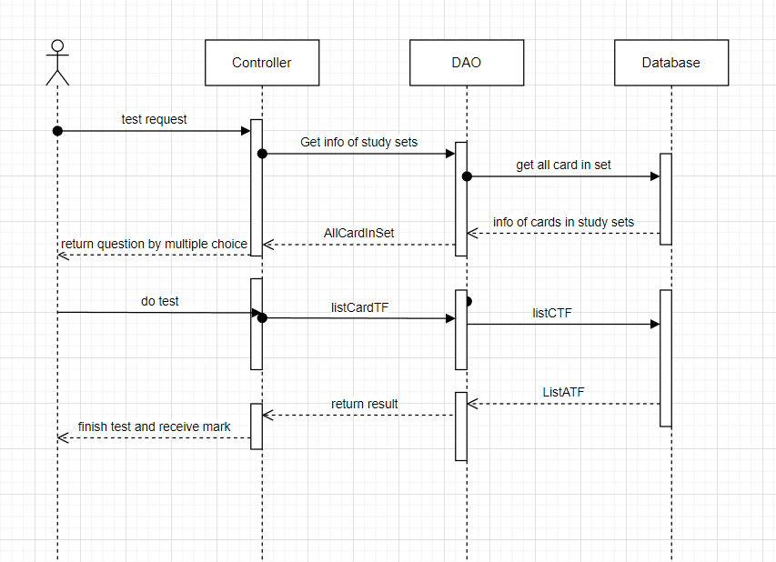

### d. Database Queries

*String sql = "SELECT [cardId]\n"*

*+ " ,[term]\n"*

*+ " ,[definition]\n"*

*+ " ,[studySetId]\n"*

*+ " FROM [dbo].[Card]\n"*

*+ " WHERE studySetID=?";*

String sql = "SELECT [cardId]\n"

+ " ,[term]\n"

+ " ,[definition]\n"

+ " ,[studySetId]\n"

+ " FROM [dbo].[Card]\n"

+ " WHERE studySetID=?";